Y10 MUSIC – HIP HOP RESEARCH PROJECT

INSTRUCTIONS:

- Your task is to research the musical style of Hip Hop. This will give you a better understanding of its background. You will also later be producing a hip hop track on BandLab!

- You should use information from websites, documentaries and books to help you. Don’t just rely on one source - try to use different websites to check that the information is accurate.

- You must write everything in your own words and you must reference your work by providing a list of any websites/books you have used. If you do not do this, your work will be ungraded due to plagiarism (copying).

- Your research can be saved in Microsoft Word or Powerpoint, or you can make a poster. Recommended word count: 500-1000 words.

- This work is due by Monday 18th May. Please email the work to your teacher:
(Tom Lancaster tom.lancaster@oasisshirleypark.org / Luke Scott luke.scott@oasisshirleypark.org)

Research the following sections to learn more about hip hop:

1: The factors that influenced its inception (how did it start?)
Provide as many points and as much detail on political, social, historical reasons behind the origin of hip hop.

Include at least 5 major reasons and explain with as much detail as possible.

Suggestions: Try Googling “how did hip hop start / evolve?”
Sentence starter: “Hip hop began in ________for the following reasons…”

For example: “Hip Hop began in the 1970s when African Americans and Latinos started up neighbourhood block parties in the poorest areas of New York. This happened because…”

STRETCH: ADD YOUR OWN OPINION TO YOUR RESEARCH e.g. “I think that…”

2: Significant artists/bands/producers
Provide a case study of at least 5 significant artists / bands / producers in hip hop
Include any facts, members and pictures of band (reference these with a website link). For each case study, explain why they are significant (e.g. how did they influence the style?)

Suggestions: Google “Significant artists in hip hop”

Sentence starter: “________________ was a significant artist in hip hop because…”

For example: “DJ Kool Herc was a significant artist in hip hop history, as he is widely believed to have thrown the first hip hop house party in 1973. This inspired others to…”

STRETCH: ADD YOUR OWN OPINION TO YOUR RESEARCH e.g. “I think that…”

3. Important recordings/performances/events
Identify at least 5 important recordings / performances / events in hip hop
This could include influential recordings, new radio/TV channels, festivals, major concerts.
You need to explain why these were important.

Suggestions: Google “Major recordings / events / performances in hip hop”
Sentence starter: “__________________ was a significant event in hip hop because…”

For example: “Blondie’s ‘Rapture’ became the first rap video on MTV in 1981. This was a significant event in hip hop because it brought many other hip hop artists into the spotlight. This meant…”
STRETCH: ADD YOUR OWN OPINION TO YOUR RESEARCH e.g. “I think that…”

4. Imagery and fashion associated with the style
Image, fashion and music are usually related. Identify the associated fashion with hip hop music.

Consider how the image represents the musical ideas. Has this changed or stayed the same through time?

Include pictures of the style (reference these with a website link)

Suggestions: Google “Fashion in hip hop”
Sentence starter: “There was a clear image/fashion associated with hip hop, with people wearing________ This represented…”

For example: “There was a clear fashion associated with hip hop, with artists in the late 1970s wearing sports brands such as ‘Adidas’ and ‘Kangol’. This represented the relaxed house party culture at the time. In the 1980s, this evolved to…”

STRETCH: ADD YOUR OWN OPINION TO YOUR RESEARCH e.g. “I think that…”

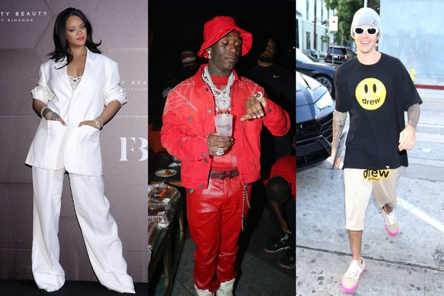

5. COMPARE TASK
Now choose a different musical style to compare your research to. Go back through the first 4 sections and add a new comment based on your new chosen style.

Look for any similarities and differences between the two styles.

Suggestions: Choose a musical style that you are interested in.
Sentence starter: “My chosen style of ________ is similar/different to hip hop because _______”

For example: “My chosen style of Punk started in a similar way to hip hop as a form of rebellion amongst the poor working class in New York. However, it was different because hip hop formed through house party culture, whilst punk music started out with bands meeting in garages.”
STRETCH: ADD YOUR OWN OPINION TO YOUR RESEARCH e.g. “I think that…”

Don’t forget to add a reference list of sources (e.g. websites, books and documentaries used)

Music Research Project – Vocabulary Guidance

Style
The style or genre of music (Blues, Rap, Country are 3 examples of different musical styles)

Inception
How this was formed. This can relate to styles (e.g. rock), substyles (e.g alternative rock) or revivals (e.g. folk revival), where young people revive older styles of music

Significant
An artist/band/producer that is either well-known within the style or has in some way contributed to its evolution

Important
A recording that received commercial, cultural, or innovative recognition

Imagery
Album covers, associated artwork, artist/band/producer stage appearance

Fashion
Clothing/accessories associated with the style. Worn or referenced by either artist/band/producer or fans

