Recommended reading for Y9s
Harry Potter series by J.K Rowling
The Subtle Knife by Philip Pullman (sequel to Northern Lights)
The Hate U Give by Angie Thomas
Pigeon English by Stephen Kelman
Noughts and Crosses by Malorie Blackman
The Fault In Our Stars by John Green
The Perks of Being a Wallflower by Stephen Chbosky
Coram Boy by Jamila Gavin
The Boy in the Striped Pyjamas by John Boyne
The Hunger Games by Suzanne Collins
Coraline by Neil Gaiman
The Lion, the Witch and the Wardrobe by CS Lewis
Booked by Kwame Alexander

Challenging texts for KS4:
Revolver by Marcus Sedgewick
The Hitchhiker’s Guide to the Galaxy by Douglas Adams
The Catcher in the Rye by J.D Salinger
To Kill A Mockingbird by Harper Lee
The Curious Incident of the Dog in the Night-time by Mark Haddon
The War of the Worlds by H.G Wells
The Day of the Triffids by John Wyndham
1984 by George Orwell

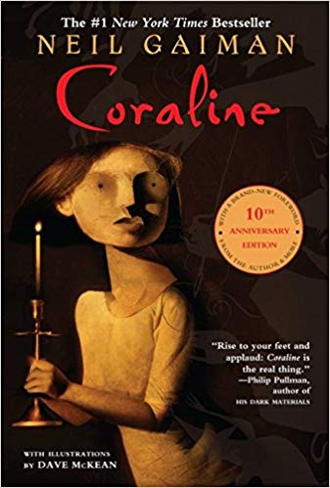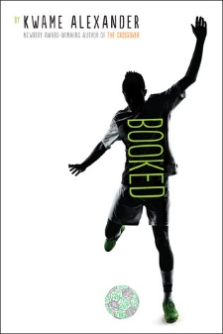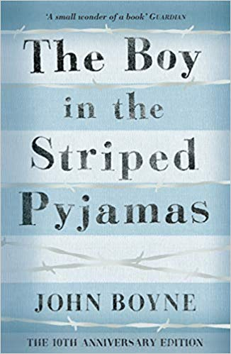

Teachers recommend:
Mr Healy: “I loved A Series of Unfortunate Events when I was younger. Lots of intertwined mysteries, evil villains and great writing.”
Ms Sampson: “Murder on the Orient Express by Agatha Christie. Such a great, addictive mystery.”
Mr Hall: “The Boy in the Striped Pyjamas explores coming of age, grief and love in an eloquent way.”
Mr Bosela: “To Kill A Mockingbird introduces young readers to topics like morality, themes which are so important to think about at that age.”
Ms Simpson: “Everyone should read The Hobbit, because it will lead you on to The Lord of the Rings, which everyone should also read!”
Mr Clerkin: “The Lion, the Witch and the Wardrobe, by C.S Lewis. The perfect example of escapism.”
Ms Kent: “The Kite Runner by Khaled Hosseini. Despite the more mature themes, it gives an eye-opening account of friendship in the face of difficulties.”

