Self-quizzing at OASP
All students receive an independent learning folder at the start of the academic year. Within this, students keep their knowledge organisers. These are A4 in size, and contain all the key knowledge that students need to know. Each subject provides at least one knowledge organiser a half term.

Students should spend at least 5 hours per week self-quizzing at home. This forms the majority of student independent learning. This is because students need to understand the key knowledge for each subject before they can use this knowledge effectively to carry out other skills such as evaluation and application. Students should also revisit older knowledge organisers, to strengthen their recall of prior learning.

To self-quiz students should:
- LOOK: students should select a section of their knowledge organiser to read over. This could be a topic they have covered in their last lesson, or an older topic that they need to revisit.
- COVER: students cover their knowledge organiser
- WRITE: students write down everything they can remember from this section (this could be on A4 paper or in a blank exercise book).
- CHECK: students check their answers against the knowledge organiser, and correct any mistakes and add any missing information in a different colour pen.

It is also possible for parents and carers to question students verbally on the key knowledge, to see how much they can recall.

It is important that students need to keep repeating this process until they understand and can recall all of the information. This can be a lengthy process, but is essential if information is to move into students’ long term memory. This means students will store the information for a much longer period of time, and can access it more easily.

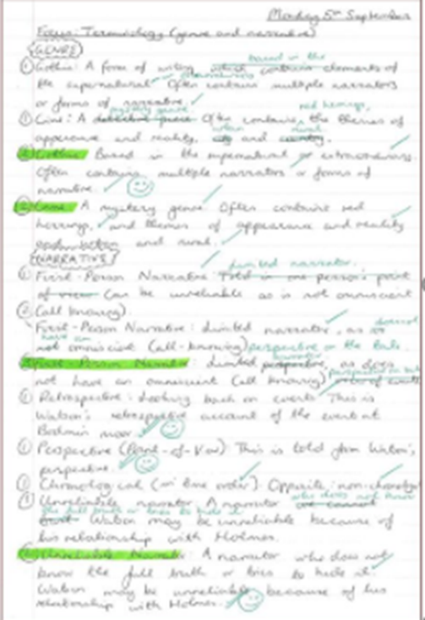
An example:
Date, topic title

Information recalled in black pen

Improvements, corrections in green pen

