Sixth Form Essay Writing Skills

Core concepts:
- Academic writing is about saying clever things in a simple way.
- Organise your ideas clearly.
- Don’t use words you don’t know the meaning of.
- Don’t waffle and faff: get straight to your plan.
- Trim your phrasing: express your ideas clearly and simply.

Contents
Sixth Form Essay Writing Skills 1
Planning 2
Writing an introduction: Othello 3
Efficiency and detail 4
Topic Sentences 4
Referring to the Writer’s Ideas 7
Situate your quotations 7
Signpost your argument 8
Assessment Objective Guide 8
Paper 1: Love Through the Ages – Shakespeare 8
Paper 1: Love Through the Ages – Unseen Poetry 9
Paper 1: Love Through the Ages – Atonement and 19th C Poetry 10

Planning
Identify the key word/s of the question.

Brainstorm out of the key words. Think about:
- Yes, because/by…
- Yes, and…
- Yes, so…
- Yes, but…

e.g.:
‘Othello and Desdemona worship each other and so drive their own downfalls.’
In the light of this view, discuss how Shakespeare presents Othello’s and Desdemona’s attitudes towards one another in this extract and elsewhere in the play. [25 marks]
I have started you off:
- Yes, they worship each other because of their idealised, unrealistic perceptions.
- Yes, they worship each other because they are isolated and each given limited independence by society so seek freedom in their relationship.
- Yes, they worship each other and so become even more detached from reality and therefore vulnerable.
- Yes, they worship each other but it is Othello’s self-worship which begins their downfalls.
- Yes, they worship each other but it is Iago’s ability take advantage of others’ worshipping (Roderigo, Cassio) that fractures their relationship.
Add your own ideas and formulate and three paragraph plan.
Write your topic sentences before you begin. E.g.:
- Shakespeare presents Othello and Desdemona’s love for each other as built on idealised, unrealistic perceptions and shows how this worshipping makes them vulnerable to Iago’s machinations.

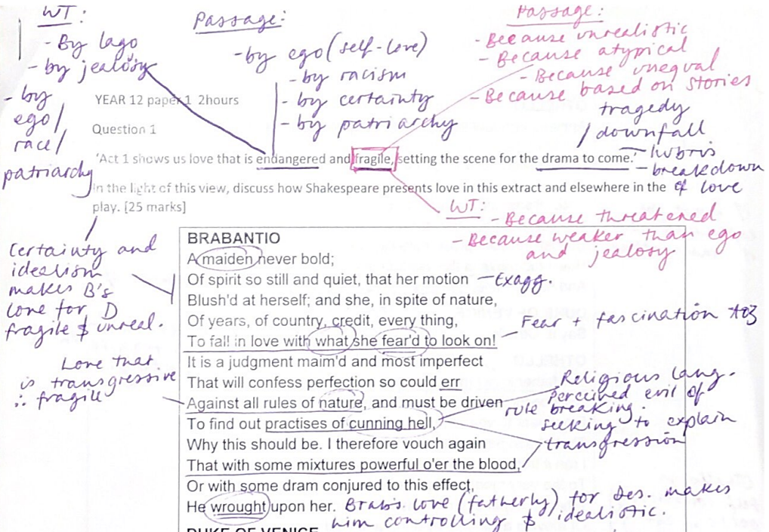

Writing an introduction: Othello

Play + key word + idea. Extract + summary + key word. Play as a whole + Shakespeare + key word.

In ‘Othello’, love is endangered and fragile because it exists in a time of conflict and prejudice. In this extract, Brabantio explains his horror at his daughter’s clandestine marriage, showing his possessive love, and Othello explains how he and Desdemona fell in love, showing his poetic skill and also hinting to his self-love. In the play as a whole, Shakespeare asks his audience to consider how love can survive amidst inequality and hubris, showing that jealousy and manipulation thrive when love is fragile.

Efficiency and detail

Efficiency means expressing yourself concisely and clearly. Many phrases that you use in your writing are like treading water: they do not get you anywhere. Which phrases does this examples use that do not get them anywhere?
When Othello says ‘let her have your voice’ it is a strong thing to say and very unusual for the time when women did not have as many rights as they do now. This is especially true because of the use of the word ‘let’ which is interesting because it shows that he is powerful. This is due to the fact that ‘let’ is an imperative verb and is therefore a powerful thing to do and shows Othello’s love for Desdemona as strong, not weak or fragile. In this example, love makes Othello stronger.
- What’s wrong with this?
- Are the points correct?
- How many point/s are being made?
- Tell your partner a brief ‘in other words’ for this paragraph.
Why is this better?
Othello’s ‘let her have your voice’ shows the power of his love, and his atypical wish to be equal with his wife, with the imperative verb ‘let’ emphasising his control and command. Therefore, Othello’s love for Desdemona empowers him, and, at this stage in the play, it arguably is not fragile.
- Nominalised – ‘Othello’s + quote + shows’
- Therefore – ‘Therefore + character’s + noun + verb’
This pupil has saved themselves time, so they can now continue writing, adding more interesting detail:
On the other hand, this unshakeable confidence is exactly what makes Othello vulnerable to threat because it is led by his ego and self-belief. Later in this scene, Othello defends Desdemona to Brabantio, saying ‘my life upon her faith’, which denotes his overconfidence and hints to a possible downfall.

Topic Sentences

Your first paragraph should announce what you’re going to focus on to help you answer the question. Without a clear topic sentence, your marker has no idea where you are going and they can see that you haven’t planned.
An essay is an argument – we propose a series of thoughts, using them to come to a clear conclusion. No one can understand an argument that is scatty.

Look at this full marks example paragraph. It is responding to the question on page 1.

First, highlight the topic sentence. Cover it up and explain it to your partner in simple English.
Then, annotate the paragraph for the following:
- Comma + present participle verb (-ing verb) used to add detail to sentence
- Subject terminology used to introduced a quote
- Quote + and, later, + quote
- Use of key words of the question
- Use of adverb to show understanding of character (e.g., ‘Cassio adds, innocently, that Desdemona is ‘indeed perfection’)
- Use of an adjective to show understanding of character (e.g., ‘Cassio’s innocent comments that Desdemona is ‘indeed perfection’)
- Subject terminology used as an adjective (e.g., metaphorical, hyperbolic, emphatic)
- Specific adjectives
- Quotations
- Reference to writer’s intentions
- A03 weaved into a sentence
- End of sentence gives a mini conclusion to sum-up the argument / topic.
In this passage, Shakespeare presents love as fragile because of societal prejudice. Desdemona is objectified from the start of the play, being referred to in the middle of the list ‘your house, your daughter, your bags’ and, later, described as ‘your white ewe’ to Brabantio. In a time of gender oppression, Desdemona’s choice to transgress and marry a black man without her father’s permission makes her relationship with him fragile and endangered by those around them. Brabantio does not respect their relationship, saying she ‘[fell] in love with what she fear’d to look on’, therefore presenting her as a pure victim and Othello as a savage. Brabantio also describes, proudly, how Desdemona was perfect in her modesty and obedience before meeting Othello, saying ‘her motion blush’d at herself’. This hyperbolic suggestion that Desdemona was so modest that even her body embarrassed her, represents the Jacobean male desire to control and suppress female sexuality and shows that Desdemona is not respected as an individual, therefore making her relationship fragile. Shakespeare seems to juxtapose Brabantio’s possessive comments with Othello’s ‘let her speak of me before her father’, perhaps suggesting that, while the world outside demeans and disrespects them, the love is strong and equal between them. However, while the imperative ‘let her speak’ initially suggests an equal love, the following ‘of me’ arguably suggests that Othello still wants to direct Desdemona. This is also shown later in the line ‘she loved me for the dangers I had pass’d /and I loved her that she did pity them’, which shows that Othello’s love for Desdemona is founded on her love and admiration of his heroism. Therefore, for both these men, Desdemona is seen as dependant and reliant, rather than fully independent. This sets the scene for the later tragic breakdown of their relationship because Desdemona is not fully respected and believed – her identity was first about how she was seen by her father, then by Othello. Shakespeare does this in order to show that love suffers in a world of prejudice, but that prejudice does not solely come from external insults and belittling – it can also come from within the relationship, even in the language of idealising. In this way, Desdemona’s status as a woman in Jacobean society ensures that her transgressive love is threatened from the very start.

Referring to the Writer’s Ideas

Writer + the big noun idea + theme/subject
+ the reality of
+ the power of
+ the complexity of
+the inevitability of
+the difficulty of / between
+ the vulnerability of
+ the pressures of
The poet explores
The poet considers
The poet examines
The poet reveals
+ theme/subject
The poet questions
The poet offers us a view of
The poet forces us to consider

e.g:
Through the repeated motif of the polka, which plays in Blanche’s head and also for the audience, Williams explores the power that memory has to overshadow and fracture the present.

*Remember: none of the writers you are studying at A Level have a specific political goal that they make explicit throughout their text and want to bash us over the head with. Shakespeare did not write Othello because he wanted to ‘stop racism’, and Williams did not write Streetcar because he wanted to ‘make domestic violence stop’. This is too direct and clunky – writers write because they have noticed and considered something about humans that they want to try and convey and express. It is not a direct, shouty, ‘stop this’ or ‘do that’. To say that is to reduce the power of these complex texts and writers. Is it about holding a mirror up to society and offering us views of ourselves and of our neighbour that are revealing, interesting and, potentially, transformative.*

Situate your quotations

It’s the difference between:
At the start of the poem, the poet uses the word ‘pillowed’ which suggests sleep and rest.
When we read this pupil’s sentence, we are not clear about:
- Where the quotation has come from
- What it means
- What it is about
And
At the start of the poem, the poet describes how he used to find his wife reading, saying that he ‘might […] find you pillowed with your books.’
This pupil would then go on to analyse, for example:
Here, the verb ‘pillowed’ has been created by Dunn in order to capture how immersed his wife was in reading, and how comfortable and idyllic it was to find her reading. Interestingly, this word also suggests death, stillness and repose, therefore showing how the reality of death has seeped into even the memory of past life.

Signpost your argument

When you move between one point/kind of evidence and another, make it clear where we are in your argument.
It’s the difference between:
Love is further portrayed as fragile through the character of Iago, who manages to manipulate Othello, taking advantage of the weaknesses that his over-confidence points to. Cassio compliments Desdemona, referring to her as ‘the riches of the ship [that] have come ashore.’ Here, Cassio aims to idealise Desdemona but also commodifies her, assigning specific value to her as you would ‘riches’.
This pupil moves from talking about Iago in a ‘yes, love is fragile’ point, to talking about Cassio in a ‘yes, love is fragile’ point. However, these are different. There is no signposting to tell us exactly how these two points link, so it feels abrupt to change focus.
And:
Love is further portrayed as fragile through the character of Iago, who manages to manipulate Othello, taking advantage of the weaknesses that his over-confidence points to. Where Iago takes advantage of existing weakness, the way that Cassio speaks about love indicates that it is fragile because it is idealised. Cassio compliments Desdemona in a similar idolatry way to the way Othello speaks, and here Shakespeare shows us that the language of love is inherently unrealistic. Cassio refers to Desdemona as ‘the riches of the ship [that] have come ashore.’ Here, Cassio aims to idealise Desdemona but also commodifies her, assigning specific value to her as you would ‘riches’.

Assessment Objective Guide

Paper 1: Love Through the Ages – Shakespeare

In this question, as throughout the paper, the assessment objectives are all assessed. As a result, almost all the words in the question should be addressed, as these are clearly connected to the assessment objectives: paradoxically, jealousy, springing from, deepest kind of love; in the light of this view, discuss how, Shakespeare, presents, feelings, this extract, elsewhere in the play.

AO1 is tested through the ways the students organise and express their ideas as they are analysing the passage and exploring the view. Value is placed on technical accuracy, appropriate use of terminology and the structure of the argument.

AO2 is set up in the requirement to 'discuss how Shakespeare presents Leontes feelings for…..' This requires analysis of Shakespeare's dramatic methods through a consideration of his use of language, imagery and other stylistic devices which determine how meanings are shaped.

AO3 is addressed when students demonstrate an understanding of the literary, dramatic and cultural contexts in which The Winter's Tale is placed. Students will show their understanding of the wider social and cultural expectations of marriage; they will also be able to explore contexts of audience reception through awareness of the different ways in which this scene can and has been performed.

To address AO4 students should link the typicality of the extract and the play as a whole to the theme of 'Love through the Ages', with particular reference to the destructive power of jealous behaviour, what may cause it, how it affects other characters and influences events. They could usefully explore the idea of tragic-comedy and the characteristic features of Shakespeare's so-called 'romances' or 'late plays'.

Finally, AO5 tests students' skill when engaging with different interpretations arising out of the point of view at the beginning of the question.

Paper 1: Love Through the Ages – Unseen Poetry

AO1 is tested through the way students organise their writing and express their ideas as they are comparing and contrasting the presentation of love. Value is placed on technical accuracy, appropriate terminology and quality of discussion.

AO2 reference to 'the presentation of love' in the first part of the question gives a clear instruction to consider the writers' methods in detail, to engage with the poets' methods and their effects, and to show how the methods open up meanings about love.

AO3 will be addressed through the students showing their understanding of the importance of contextual factors and in the way they will elicit from the poems contextual ideas about love within an historicist perspective (e.g. feminism and modernism).

AO4 will be addressed through students making connections between the poems in terms of subject matter or poetic methods, and by connecting implicitly with concepts of the theme of love (and other texts which address the theme) through the 'aspects' which they are exploring.

AO5 will be addressed when students grapple with meanings that arise about love and its presentation in the poems. Critical viewpoints might be used to help advance the argument, or to offer alternatives.

How the question meets the Assessment Objectives
In this question, as throughout the paper, the assessment objectives are all assessed. As a result, all the key words in the question should be addressed, indicating either focus (how authors present, barriers to love) or direction (compare, two texts).

Paper 1: Love Through the Ages – Atonement and 19th C Poetry

AO1 is tested through the way the students organise their writing and express their ideas as they are comparing how barriers to love are presented. Students will need to use coherent, accurate written expression in their answer in order to compare efficiently and in doing so will use appropriate concepts and terminology.

AO2 is set up in the requirement for students to explore the writers' methods and their effects, signalled by the word 'present', and to show how the methods open up meanings about intense emotions and barriers to love. Students should illustrate their answers with relevant textual detail wherever possible – with quotations and other close reference – to support the points in their comparison and discussion.

AO3 is addressed when candidates demonstrate an understanding of the various contexts of barriers to love, for example class, racial, physical, religious, political, emotional, permanent and temporary. In exploring the nature of barriers to love as presented in their two texts, students will engage not only with the specific context of Love through the ages, but also with the contexts of when texts were written and of reader response.

To address AO4 students will make comparisons between their two chosen texts, as directed in the question, and will connect to a wider awareness of barriers to love and the many forms its representation can take in literature of Love through the ages.

AO5 will be addressed when students grapple with meanings that arise about barriers to love in the texts and show an understanding that through comparison different meanings can be opened up. Critical viewpoints might be used to help advance the argument, or to offer alternatives.

