Key terms
Satyagraha | A form of protest that involved peaceful non-cooperation. Crucially, it was an active form of non-cooperation. i.e. Steps had to be taken to place the Raj in discomfort. | Purna Swaraj | The term meaning ‘total self-government’ or ‘independence’ for India. This was the decreed objective of Congress following the Lahore Congress.
Ashram | A community, often monastic, in which a basic and simple life Is pursued. In the context of India, Gandhi favored life in an Ashram where a peasant life could be pursued. | Salt Tax | A tax on India’s salt exports and internal revenues. The tax brought 4% of the total government revenue for a year, but was an emotive issue. Everyone in India had to pay the tax, and salt was essential to everyday life in India.
Charka | A spinning wheel. This became the symbol of the Congress party. Gandhi believed that daily spinning by India’s leaders would not only bring them into closer contact with the realities of peasant life, but would also enhance the dignity of labor in the minds of India’s intellectuals, who had never had to do hard physical work. | Salt Satyagraha | A peaceful protest against the Raj’s Salt Tax. The protest was made up of a march of Gandhi and 78 men (carefully chosen to include all members of Indian society e.g. untouchables) who were followed by crowds of thousands as they marched across India. After 240 miles, Gandhi reached the coast and symbolically picked up salt from the sea as a rebuke to the British. He encouraged Indians to follow suit and pick up ‘free salt.’
Mahatma | Usually translated as ‘the Great Soul’. In India, this title is bestowed on someone who is deeply revered for wisdom and virtue. | Khalifat Movement | A pan-Islamic political protest against Britain during WWI, in defence of the Ottoman Caliphate that was attacked by Britain. The movement spread rapidly throughout India in the 1920s and was supported by Hindus such as Gandhi.
Jawarhalal Nehru | One of the ‘Young Hooligans.’ Nehru was in favor of total independence from the Raj, yet was willing to work alongside Gandhi to achieve this through non-violent means. | Mohammed Ali Jinnah | The principle Islamic political leader in India. He was a member of Congress within the early 1920s but became increasingly frustrated with Gandhi, who he felt was not in favor of safeguarding a separate Muslim electorate. He left the party in the mid 1920s.
Swaraj | The term meaning ‘self-government’ in India. This was the principle aim of India’s political leadership in the years between WWI and the Lahore Congress. | Anjuman Tabligh-ul-Islam | A gathering or association (anjuman) for the promotion of Islam. In the early 1920s, the Tanzam and Talibagh movements aimed to strengthen Islam through the foundation of these in every town.
All-Indian spinners association | An organization founded by Gandhi aimed at promoting the skills of spinning and weaving as a means of self-sufficiency. This was in line with the Gandhian philosophy of ‘back to basics’ and a reversion to peasant life within the subcontinent. | Muslim separatism | The belief in Muslims separating from the dominant political group, and seeking autonomous government of their own community.
Congress working committee | A sub-set of the All-India Congress Committee (AICC). Its job was to formulate policy, therefore mirroring what a cabinet was to a government. Gandhi was seeking to create a system whereby an alternative system of government was in place in the event of a British withdrawal from India. | Arya Samj | A Hindu organization operating in northern India which openly criticized Islam. They introduced the Cow Protection Society, bringing them into open conflict with Muslim butchers and tradesmen
‘Young Hooligans’ | Subhas Chandra Bose, Jayaprakash Narayan and Jawaharlal Nehru. They lobbied the AICC in the 1920s and made it clear that their objective was one of independence. | Bakr’Id | A Muslim festival in which cows were ritually slaughtered. Cows are animals that are considered holy to Hindus, thus causing deep offense.
Dominion status | Dominions were self-governing countries within the British Empire. Dominion status would give Indians the right to control their own internal affairs. | Holi Festival | A Hindu festival that involved the lighting of bonfires and dancing on the streets. The noisy method pf prayer jarred with the Muslim silent prayer.
Subhas Chandra Bose | A member of the young hooligans. He was more radical than Nehru, and favored violence if necessary to achieve total independence from British rule. | Viceroy Irwin | A viceroy in India determined to bring about conciliation between the Raj and the Indians.
Nehru Report | The first draft of a future constitution for India. The report suggested India should be granted the same form of dominion status as that enjoyed by the white, self-governing dominions of the Empire, such as Canada and Australia. | Simon Commission | In 1927, the government sent a parliamentary delegation, headed by Sir John Simon, out to India to find out how the Government of India Act was working. The commission made no attempt to consult Indians, and sent a message that the future of the subcontinent would be determined by British politicians.
Motilal Nehru | Jawarhalal’s father, he was a conservative member of Congress and drafted the Nehru report. | Irwin Declaration | A re-affirmation of the Montagu declaration. It promised dominion status to Indians, and invited Indians to a round table conference in London to form a new constitution.
Lahore Congress | The Congress meeting in 1929 that established Congress’s objective of Purna Swaraj. Gandhi left the congress with a working committee dedicated to this objective. | Gandhi-Irwin Pact | A deal between Gandhi and Irwin that promised the Congress civil disobedience campaign would end, in return for 19,000 congress supporters being released from jail.
Why did Gandhi emerge as leader of Congress? | Examples | Impact
Popularity of doctrine: Gandhi’s philosophy was underpinned by the concept of Satyagraha. His quest for passive resistance to British rule was central to his core beliefs, along with his firm affirmation of the idea that Indians should revert to a peasant-based lifestyle. Gandhi also offered a style of politics that combined spiritual strength with political awareness. | - Gandhi fervently believed, and spread the doctrine, that western technologies had failed and brought little benefit to Indians. Gandhi claimed that people had become slaves to machine.  - Gandhi promoted the idea of Indians living in small, self-sufficient communities.  - Gandhi himself rejected western norms and pursued a life adherent to traditional Hindu culture, living in an Ashram. | - Gandhi’s derision of western technologies found favor with an urban mass who had become displaced by technological advancements in their fields of work.  - Gandhi’s message of small, self-sufficient communities, while unworkable, found support amongst India’s peasant population, with Gandhi being seen as someone who they could identify with.
Lack of political competition: Gandhi emerged as the congressional political leader following WWI, largely on account of his own immense political appeal. The lack of political alternatives, and the weakness in the doctrine of congress, ensured that Gandhi was able to position himself as unquestioned leader of Congress in the 1920s. | - Bal Tilak died in 1920, and Bessant was seen as a woman of little consequence. The leaders of the Home Rule movement were therefore unable to challenge Gandhi.  - Congress was divided amongst themselves with regards to which path to follow in order to achieve what they wanted, so couldn’t offer a united front against Gandhi | - There was no other politician acting in the way Gandhi did, with regards to the adoption of peasant values. This led to people calling him the Mahatma.  - There were no other politicians, or even bodies of politicians within India, with anywhere near the level of local support as Gandhi. Congress really had no choice but to align themselves with Gandhi as he offered support for congress.
Engagement of rural masses: Gandhi’s adoption of traditional Indian practices and rituals that focused particularly on aligning himself with India’s peasantry, engaged the political support of a broad population of India’s Hindus. Gandhi was able to engage an area of the population in Indian politics who had previously been untouched by political machinations in the subcontinent. | - Gandhi began wearing a Dhoti, sending the message that all Indian’s clothes should be made from local materials.  - Gandhi began eating and moving like the peasants, eating only vegetables and walking everywhere he could  - Gandhi began a routine of daily spinning, using a charka on a daily basis.  - Gandhi involved himself in local issues and disputes, and campaigned for the masses. | - Gandhi’s adoption of these peasant values aligned him with the vast majority of Indians (roughly 90% were peasants). Acts such as spinning the charka brought him into close contact with the millions of Muslim inhabitants of India  - Having taken a leading role in settling local disputes across India, Gandhi had widespread support across all areas of India, giving him a geographical advantage.
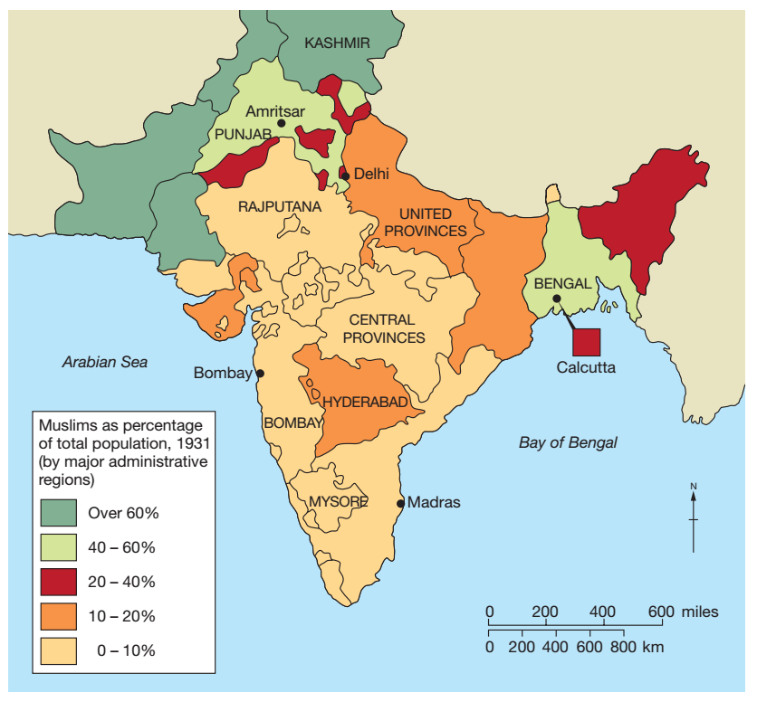
India Unit 2:
Changing political relationships 1920-30

How effective was non co-operation in the early 1920s?
Effective | Not effective
- Gandhi pushed through doctrine of Stayagraha at Congress 25th annual meeting, Nagpur 1920. Was able to convince Congress non-cooperation would result in Swaraj  - Gandhi was mindful of failed satyagraha following Rowlatt Acts – he targeted areas of non-cooperation that would not bring protesters into conflict with the police  - There was some initial success, for example students boycotted their examinations, taxes were not paid, a large number of qualified voters stayed away from the 1920 elections, around 200 lawyers stopped work and, during the visit of the Duke of Connaught to Calcutta in 1921, shops were closed throughout.  - Congress were able to grasp a greater awareness of the specificity of peasants needs. For example, Jawaharlal Nehru, a barrister with a privileged background and a member of Congress, decided in the summer of 1920 to travel extensively in Awadh, a region in the centre of what is now Uttar Pradesh but was then known as the United Provinces of Agra and Oudh – and the province of his birth. What he found there was miserable poverty, but combined with a sense of excitement that change was in the air. | - Millions of Indians failed to grasp the principles that underpinned satyagraha and used it as a means to settle old scores  - Violence broke out at different times in different provinces. In Bombay, for example, a hartal designed to coincide with the visit of the Prince of Wales turned into four days of looting and rioting, leaving 53 dead and hundreds injured.  - In Rangpur, the mob attacked moneylenders. The Muslim Moplahs of Malaba declared a jihad, killing British people and wealthy Hindu and Muslim landlords and moneylenders, as well as forcing Hindu peasants and laborers to convert to Islam.  - In the Punjab, and later in the Gangetic Plain, the Deccan and other parts of India, Hindus forced Muslims to ‘purify’ themselves by total immersion in water tanks and rivers, resulting in many drownings. The always fragile Hindu–Muslim alliance was in serious jeopardy. Satyagraha was spiraling out of control.  - Matters came to a head in February 1922 when a mob of Congress supporters torched a police station in Chauri Chaura, a village in Gorakhpur, burning alive 22 Indian policemen. Gandhi immediately withdrew to his ashram to fast and meditate, emerging a few days later to call an end to the non-cooperation campaign.  - Less than a month after calling for the campaign, Gandhi was arrested and imprisoned.

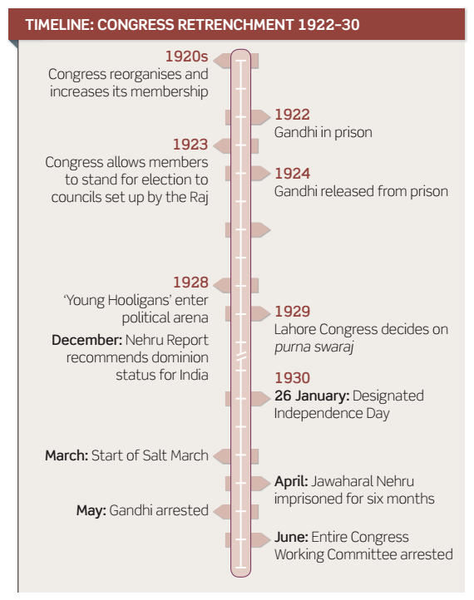

Reasons for growth of Muslim separatism | Examples | Impact  Increasing support for Congress under Gandhi  - During period of non-cooperation, Congress rose from a membership of 100,000 to 2 million by end of 1921.  - Cooperation with the Raj was to end and was to be replaced by non-violent non-cooperation.  - Membership of the All-Indian Congress Committee was increased from 161 to 350 and seats were re-allocated on a regional population basis.  - Great emphasis was placed on recruiting women and from hitherto untapped groups like trade unions. Around 100 additional provincial committees and several hundred more local branches were set up.  - Gandhi set up Congress Working Committee while also going ‘back to basics.’ He set up the All-India Spinners’ Association, with the intention of spreading the word about hand spinning and weaving as well as promoting the general cause of self-sufficiency.  - Gandhi persuaded a willing Congress to embark on campaigns of mass literacy and for the improvement of village sanitation. Gandhi himself began to campaign vigorously on behalf of the ‘Untouchables’ in order to enable them to enter fully into Indian society.  - This period is characterised by Congress developing into a responsible political body, capable of combatting the Raj through legal and political means, while also improving the lives of India’s millions of subjects.
Religious differences: India was a country which essentially comprised of a 70% Hindu population, and a 25% Muslim population (the rest were made up of minorities like Sikhs). The Lucknow Pact had showed a willingness amongst both religions to move forward as a united front against the British. However, deeply ingrained religious differences played their part in creating tension between both religious communities. | - Hindus liked to use gongs, bells and cymbals to create loud music when they were worshipping. Muslims preferred to pray in silence.  - At the Muslim festival of Bakr’Id, cows were ritually slaughtered. But the cow was sacred to Hindus. On the other hand, the Hindu festival of Holi was particularly noisome and troubling to Muslims. | - As a result of religious differences, organisations emerged aimed at preserving the distinct religious practices of both communities. The Hindu criticizedn Arya Samj was proactive in the Muslim community in parts of northern India. Members openly criticized Islam and sought converts to Hinduism. They argued for the protection of cows, sacred to Hindus, and established the Cow Protection Society,.
The Raj: Throughout her imperial history, the British pursued a policy of ‘divide and rule.’ This consisted of fomenting dissent amongst the population of a given country, so that they may oppose one another, as opposed to forming a united front against Britain. This philosophy was pursued by the Raj in the years following WWI, where Britain were eager to elevate the standing of India’s Muslim population. | - Throughout the proposals the Raj put forward to enable Indians to participate in government at all levels, there was a common thread of protecting the rights of minorities by making provision for separate electorates.  - The Montagu Declaration and Government of India Act safeguarded Muslim interests. This all formed part of the broader imperial philosophy of ‘divide and rule.’ | - In doing this, while ensuring that Muslims had a voice in local and national a airs, the Raj ensured that the concept of separateness was further emphasized and enshrined in the political solutions they had to offer.  - The Raj created a focal point of discontent. Many in Congress felt that a united front against the Raj was the best course of action if Purna Swaraj were to be achieved, yet in doing so alienated their Muslim membership.
Political forces: During the 1920s, various political forces shaped the direction of progress for both Hindus and Muslims. The emergence of the Khalifat movement showed that Muslims were prepared to be unified under an Islamic message, while Gandhi’s involvement in the movement was seen by Muslim leadership as duplicitous. The emerging strength of congress as a national body capable of taking on the Raj, coupled with the growth in the feeling of isolation and vulnerability amongst the Muslim population of India. | - Many Muslims, including Jinnah, left Congress after what they saw as a failure by Congress to support them over their concerns about the breakup of the Islamic ottoman empire.  - The Khalifat movement spread rapidly throughout India, legitimizing Muslim participation in nationalist movements. Gandhi joined and led the movement in India, but many Muslims became uneasy with his leadership.  - Hindu members of congress began to vocally regret the generous electoral promise given to Muslims at Lucknow. | - Muslim membership in Congress had dropped from 10% in 1921 to 3% in 1923.  - Muslims turned to movements such as the Tanzeem and Tabligh movements which aimed to strengthen Muslim identify in communities across India. They insisted every town would have an Anjuman Tabligh-ul-Islam. These bodies focused on the plight of Muslims at the hands of Hindus and anti-Hindu sentiment grew rapidly.

British action
Simon Commission  - Government of India Act up for review in 1929 – Conservative government were fearful that, by that time, labor would have won the 1929 general election and give Congress what they wanted. Conservatives therefore brought the review forward to 1927.  - Labor were traditionally more left-wing, and had close links with congressional leaders. Concepts such as socialism were prevalent within the labor party, and were concepts adhered to by influential congressmen such as Nehru. Traditionally, Labor were far more likely to grant India some form of independence, than the conservative party, who had a legacy of pro-Empire rhetoric,  - 1927, conservatives sent delegate, Sir John Simon, to India to review how well the government of India Act was working. Simon headed a delegation of 7 men- none of these were Indian men. | Irwin Declaration  - May 1929, Labor government is elected. was very different from the response that the previous Conservative government might have made. The new prime minister, Ramsay MacDonald, was sympathetic to the demands of Congress and so was the new secretary of state for India, William Wedgwood Benn.  - At the same time, Viceroy Irwin was determined to bring about some form of resolution in India. He met with Labor party leaders and stated his two goals; a conference to discuss future reforms and a declaration that the Raj’s goal for India was dominion status.  - 31st October 1929, Irwin issues his declaration. He stated that dominion status was the ‘natural future’ for India, and that Indian delegates would be invited to a Round Table conference in London. The Congress Working Committee asked Irwin for amnesty of all political prisoners but he refused. | Gandhi-Irwin Pact  - By 1930, Gandhi and Nehru were imprisoned and there was a clear stalemate.  - Viceroy Irwin was fearful that Congress would find a way to end the stalemate by pursuing a campaign of violence. He wanted to create a situation in which Gandhi could leave prison and participate in the London Conference as the representative of Congress, yet he himself couldn’t be seen to negotiate openly with someone the authorities regarded as a terrorist.  - A meeting between Gandhi and Irwin was brokered by India businessmen, who were aware that any further civil disobedience would disrupt their own interests. In February 1931, the two leaders met. They agreed on the following; Congress to end campaign of civil disobedience, Gandhi agreed to attend a second London conference, 19,000 congress supporters released from jail, confiscated property returned to its owners.
Consequences and impact
- The message appeared to be that the future of India would be determined by white British men, and would not take into account Indian’s themselves.  - When the delegates arrived in Bombay, they were greeted by booing, jeering crowds carrying banners, waving black flags and shouting slogans like ‘Simon, go home!’ It was the same in Calcutta, Delhi, Lahore, Lucknow, Madras and Patna. Everywhere the Commission went, they were met with mass demonstrations, which the police could hardly control.  - Members of Congress, Hindu leaders, liberal thinkers and a large section of the Muslim League led by Jinnah decided to boycott the Commission and refused to give evidence to its commissioners.  - On the other hand, Muslims from the provinces where they were in a majority decided to help the Commission’s enquiries, as did a number of Anglo-Indians, Sikhs and Untouchables. All of these minority groups hoped for a better future than that which they were anticipating under a Hindu-dominated Congress. The report was eventually abandoned before publication. | - Gandhi, like the rest of the Congress leadership, knew that to attend the London conference would be political suicide. Not only would they be on ‘foreign’ soil, but they would also be forced to follow a British agenda.  - What was worse, the British weren’t just expecting representatives of Congress to attend the proposed conference. All representatives of Indian opinion were expected to be there: Sikhs and Untouchables, for example, as well as the princes, whom Gandhi regarded as nothing better than pawns of the British.  - The chances of Congress getting what they wanted would, Gandhi believed, be severely compromised. On the other hand, not to go to London would probably result in a settlement being made to which Congress – and Gandhi – could not possibly agree. | - Paved the way for Congress, and Gandhi, to participate in the Round Table conferences, offering the opportunity for some form of political reconciliation to be brokered between Congress and Britain.  - The suspension of civil disobedience allowed India to stabilize, and its economy benefitted as a result. ‘Normality’ returned to the subcontinent.  - Some congressional leaders, such as Nehru, felt that Gandhi had betrayed India, by stopping his civil disobedience movement at a time when it had clearly become damaging to the British. Gandhi argued that this was merely an interval, and an opportunity for rest, in the great struggle against British imperialism and fight for independence.
Salt Satyagraha
- Salt Tax identified as suitable protest point as it had the ability to engage the masses. Gandhi undertakes Satyagraha which attracts thousands. The march took on the character of a pilgrimage: every day the 78 participants were supposed to spin cotton thread, pray, keep a diary and at all times behave in a non-aggressive, peaceful manner. Also accompanying Gandhi was a posse of reporters and cameramen from the world’s press who faithfully reported his message of non-violence.
- In June, the entire Congress Working Committee was imprisoned, along with Gandhi. This led to the second major campaign of satyagraha. Unlike previously, there was no central direction, but instead provinces determined how the satyagraha would be pursued in their own regions.
- By the middle of the year, all provinces in India had been affected, with Bombay and Gujarat being the most turbulent. For example, parts of Bombay were in the hands of the mob and were no-go areas for police.
- Replicated on a national scale, the level of disturbance was impressive. Civil disobedience became the vehicle whereby a whole range of people, from students to middle-class businessmen, became politically aware and articulate. Women, in particular, became actively involved, often because the men in their families had been imprisoned, but in their own right, too, and not as substitute males. By November 1930, nearly 360 women were in jail for their participation in different satyagraha’s.
- However, by early 1931, the Raj had more or less restored law and order. Official estimates say that around 60,000 people passed through India’s jails in 1930. This had put an immense strain on the civil service, police and magistrates of the Raj, as well as causing intolerable overcrowding in the jails. Indeed, by the end of 1930, there were still some 29,000 people in India’s jails, including 300 women and around 2,000 youths under the age of 17.
Changes under the Young Hooligans
- The young hooligans relentlessly lobbied the All-Indian Congress Committee and the Congress Working Committee. They wanted renewed action and they wanted it now. Independence, and the freedom that it would bring the Indian people, was their ultimate objective and they were impatient with what they perceived to be Congress’s reluctance to confront the Raj.
- The Nehru Report (drafted by Motilal Nehru) recommended Dominion Status for India and put forward a draft constitution for the future of India within a dominion role. It suggested that the princely states and British India were to be joined in a federation. There would be no further devolution of power to the provinces. However, this meant in effect that Hindus would form a permanent majority within central government. Despite vague promises that religious freedoms would be safeguarded and new Muslim states created, most Muslims were deeply unhappy. The young hooligans opposed this, saying it did not go far enough.
- Divisions occurred in Congress regarding the concept of dominion status. Congress was divided over whether they would accept such a proposition from the British, or favour the young hooligans’ doctrine of total independence. When Congress met in Lahore, a policy decision could no longer be shelved. Gandhi had made up his mind: he would support the young hooligans. He steered his policy through the various Congress committees and a militant open session, and ended up with a working committee of his own choosing to direct Congress’s actions in the months ahead. Henceforward, purna swaraj (total independence) would be India’s new political demand. Congress left it to their Working Committee to decide how and when the non-violent confrontation was to begin, and the Working Committee left the decision to Gandhi.

