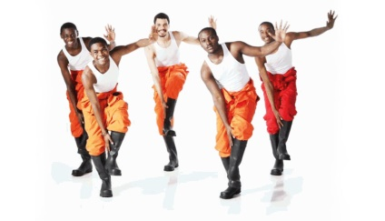
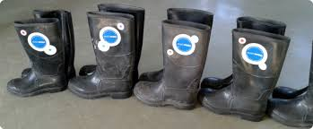
Relationships: How the dancers interact with each other during a performance. For example: mirroring, action and reaction, lead and follow.

Dynamics: The quality of each movement. For example: smooth, rigid, slow, and abrupt.
Keywords: Performance, Stylistic feature, Movement, Unison, Control, Timing, Choreography, Rhythm, Mental skills
Space: • pathways • levels • directions • size of movement • patterns • spatial design.
Action: Travel, Turn, Transfer of weight, Jump, Gesture, Stillness
Action, space, dynamics and relationships
Gumboot Dancing
An African dance style that was performed in the mines as a way to communicate.
Slapping Clapping Stomping Gumboots Chanting Unison On the spot Line

Year 7 Dance Knowledge Organiser

Motif Development
Canon Unison Change of levels Formation
Change of pathways Fragmentation
Cumulative canon Direction Use of travel

Contemporary Dance
A modern dance style that uses elements of ballet and jazz. Features of this dance style include:
Jumps Leaps Turns Soft Flowing Parallel Travelling
In and out of the floor

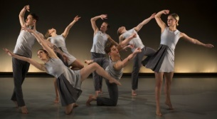
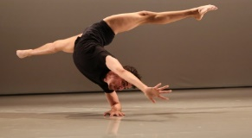
Target | Definition | Action steps to improve my target
Projection | The amount of energy or effort put into each action. | - Keep your eye-line high  - Put 100% energy/effort into each movement
Focus | The dancer’s line of sight | - Keep your eye-line high consistently throughout the performance. Use the mirrors to check you are doing so  - Look up and over the audience’s head
Timing | Using the same counts to them music as the other dancers in the group | - Use the mirrors  - Ask for peer/teacher feedback  - Use counts
Mental skills | Confidence, commitment, concentration and movement memory | - Remain professional throughout the performance and ensure you do not talk.  - Use rehearsal time effectively to support the recall of accurate movement
Show evidence of motif development | Create new movement through developing existing material. Devices that can be used are: canon, levels, direction, pathways, formation and use of travel | - When creating new movement, use the listed devices to support the creation of new movement.
Explore a range of movement, that is creative and inspiring | Do not simply stick within your comfort zone when choreographing. Push the boundaries, and create new, exciting material  Recipe for great peer feedback  A strength of your performance/ choreography was (insert from above). An example of where this could be seen in your performance was when …………… This had a positive effect on your performance because……..  An area for development within your performance is (insert from above). In order to further improve you now need to (insert from above). | - Attempt to initiate each movement with a different body part  - Research a variety of difference dance styles to gain inspiration
How can we improve our performance and the quality of choreography?
Area for development
Strengths

