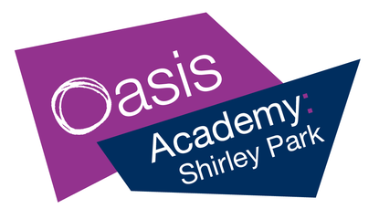

MUSICAL CREATIVITY AT HOME

Channelling creativity alongside academic study could really benefit your child whilst schools are closed. Aside from being a fun way for young people to express themselves, music is well documented to reduce stress and anxiety, whilst also improving memory, cognition and key life skills.

Read on for some ideas on how you can encourage creativity at home through music…

Does your child have an instrument at home?

- Yes? Great! Encourage them to keep practicing. This can include warmups such as scales, pieces they have been learning or starting something new. See page 2 for free resources.
- No? No problem. If you have a phone, tablet or computer, you can use apps or websites to help you. See page 2 for more details.

Alternatively, you can get creative by making your own instruments from household items and packaging (visit tinyurl.com/homeinstruments), or work on singing/rapping with the resources on page 2.

The OASP Music team will update this page with new ideas when we find them

Keep up to date with our latest resources at: tinyurl.com/oaspmusic

Contact Tom Lancaster (tom.lancaster@oasisshirleypark.org) for more info and support

Free resources

Websites – ways to learn new songs and techniques
- Ultimate-guitar.com – a huge popular music database of chords, tabs and lyrics. Applies to many instruments including keyboards, guitars, bass and vocals. Search for ‘chord charts’ online to know which notes to play for each chord on your instrument.
- YouTube.com – huge number of tutorials for all instruments. Type in the name of the instrument followed by ‘tutorial’. Also many backing tracks for rappers and singers.
- IMSLP.org – database of classical music sheet music to improve your sight reading.
- freedrumlessons.com - video drum lessons, articles and sheet music to get you drumming.
- tinyurl.com/mfplayalong – band work resources that teach you to play along with backing tracks
- apps.musedlab.org/aqwertyon – improvise, learn and make music alongside YouTube videos with your computer keyboard

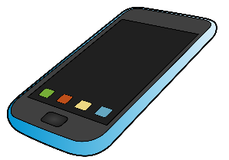
Instrumental/singing apps – turn your device into an instrument and teacher
- joytunes.com/simply-piano – fast and fun way to learn the piano for all skill levels
- Yousician.com – thousands of songs, exercises & lessons on guitar, bass, piano, ukulele, singing
- UberChord.com – learn guitar with real-time feedback
- musical-u.com/apps/singtrue – vocal training to help you sing in tune
- apps.musedlab.org/groovepizza – a pizza-shaped drum machine - explore famous beats or make your own
- VirtualDrumming.com – turn your computer keyboard into a drum

Music technology – produce your own music online
- LearningMusic.Ableton.com – a good starting point to understand how music is produced, before moving onto BandLab
- Edu.BandLab.com – To start, click ‘Start as a student’, type the invite code ZBIWINX and follow the instructions. Once you have created an account, you will be able to access the programme and start making your own music. We will be able to see what you child is working on and give feedback.

Music theory – develop your understanding of how music works
- Musictheory.net – lots of games, lessons and exercises for improving understanding of music theory
- tinyurl.com/theoryrocks music theory in a really engaging and easy-to-understand, visual way
- GCSEPod.com – learn grades 1-5 music theory (years 9-11 have access)

