Grimms’ Tales
By Jacob and Wilhelm Grimm
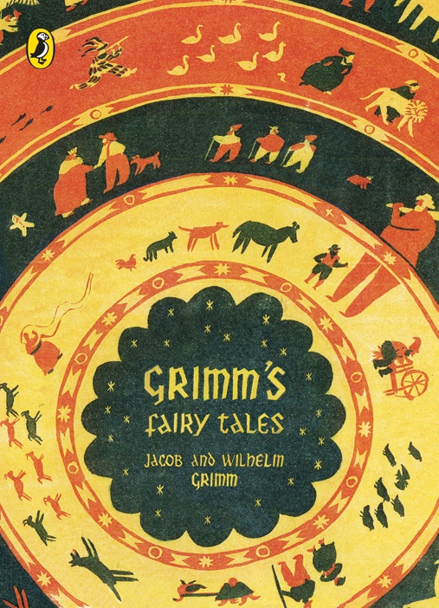

Name
Teacher & Class

Core Knowledge Lesson 1: Introduction to the Brothers Grimm
When you think of fairy tales like Cinderella and Snow White, you probably think of them as being stories for children. You will indeed find many children's versions of these stories in books and in movies. However, these stories were not always considered to be just for children, as you can see by in the work of the Brothers Grimm. When Jacob and Wilhelm Grimm published their famous collection of German fairy tales, the two brothers were heavily criticised because the stories were not seen as suitable for children. The ideas about society and the graphic (horrible and violent) subject matter was seen as transgressive and in later versions of the books many of these original ideas were taken out.
The brothers were interested in German mythology, and they saw these folktales as being part of the German mythology tradition. Of course, the Brothers Grimm realised that many of the folktales they collected had a special appeal for children. So when they published their first collection of German folktales in 1812 they called it Kinder- und Hausmärchen, or, Children's Tales and Household Tales. These were stories for children - but also stories not for children, stories for the "household." In order to understand what that means, you must try to imagine what life was like in 1812. At that time, there was no television, no radio, no internet, so storytelling was an entertainment shared by the whole household, not just children. Sitting around and telling stories was the equivalent of watching TV or listening to the radio.
The Brothers Grimm didn’t write the stories themselves, they collected them from storytellers around Germany. This means that the stories often reflect ideas that were held unquestioningly by many in Germany at the time, such as faith to the King, hierarchy, the patriarchy, the Divine Order and the idea that the King should have total power and control.
faith (n)  faithful (adj) | Remaining loyal, supportive and obedient | In the 19th century the working class were expected to be faithful to their upper class masters.
unquestioning (adj)  unquestioningly (adv) | Accepting something without doubt or question | The working class unquestioningly accepted the idea that God chose the King.

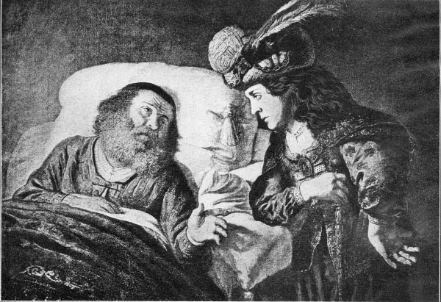
Faithful Johannes Part 1
Once upon a time there was an old king who was ill. He thought, "I am lying on what must be my deathbed," then said, "Have faithful Johannes come to me."
Faithful Johannes was his favourite servant, and was so called, because he had been so loyal to him for his whole life long. When he approached the bed the king said to him, "Most faithful Johannes, I feel that my end is near. My only concern is for my son. He is still young and may not always have the best judgment. I will not be able to close my eyes in peace if you do not promise to teach him everything that he ought to know, and to be his foster father."
Faithful Johannes answered, "I will not forsake him, and will serve him faithfully, even if it costs me my life."
At this, the old king said, "Then I will die in comfort and peace," adding, "After my death, show him the entire castle -- all the chambers, halls, and vaults, and all the treasures which lie therein. But do not show him the last chamber in the long gallery, which contains the portrait of the Princess of the Golden Roof. If he sees that picture, he will fall violently in love with her, will fall down unconscious, and will put himself at great risk for her sake. You must protect him from that, Johannes: that’s the last thing I ask of you"
Faithful Johannes gave his promise, and the old king lay back on his pillow and died.
After the old king had been carried to his grave, faithful Johannes told the young king all that he had promised his father on his deathbed, and said, "I will surely keep my promise, and will be loyal to you as I have been loyal to him, even if it should cost me my life."
When the mourning was over, faithful Johannes said to the young king, "It is now time for you to see your inheritance. I will show you your father's castle." Then he took him everywhere, up and down, and let him see all the riches and the magnificent chambers. But there was one chamber which he did not open, the one that contained the dangerous portrait. Now the portrait was so placed that when the door was opened one looked straight at it. It was so masterfully painted that it seemed to live and breathe and to be the most charming beautiful thing in the whole world.
The young king noticed that faithful Johannes always walked past this one door, and said, "Why do you never open this one for me?"
He replied, "There is something in there that would frighten you."
The king answered "I have seen the entire castle, and I want to know what is in this room as well." And he was about to break open the door by force.
Faithful Johannes held him back, saying, "I promised your father before his death that you should not see inside this chamber. It could bring great misfortune on you and on me."
"Oh, no!" replied the young king. "If I do not go in, it will be my certain downfall. I shall have no rest day or night until I have seen inside with my own eyes. I shall not leave here until you have unlocked the door."
Faithful Johannes saw that there was no other way. With a heavy heart and many sighs, he took the key from the large ring. After opening the door, he went in first, thinking that he could block king's view of the portrait, that the king would not see it in front of him. But what good did it do? The king stood on tiptoes and saw the portrait over faithful Johannes's shoulder. After seeing the girl's portrait, which was so magnificent and glistened with gold and precious stones, he fell unconscious to the ground.
Faithful Johannes picked him up, carried him to his bed, and sorrowfully thought, "Misfortune has befallen us, dear Lord. How will it end?" Then he strengthened the king with wine, until he regained consciousness.
The king's first words were, "Oh, whose portrait is that beautiful picture?"
"That is the Princess of the Golden Roof," answered faithful Johannes.
The king continued, "My love for her is so great, that if all the leaves on all the trees were tongues, they would not be able to express it. I will risk my life to win her. You are my most faithful Johannes. You must help me."
The faithful servant thought to himself for a long time how to approach the matter, for it was difficult even to come into view of the king's daughter. Finally he thought of a way, and said to the king, "Everything which she has about her is of gold -- tables, chairs, dishes, cups, bowls, and household implements. Among your treasures are five tons of gold. Have the royal goldsmiths fashion one ton into all manner of vessels and utensils, into all kinds of birds, wild beasts, and strange animals. She will like these things, and we will go there with them and to try our luck."
The king summoned all the goldsmiths, and they had to work night and day until at last the most splendid things were prepared. When everything had been loaded on board a ship, faithful Johannes disguised himself as a merchant, and the king had to do the same thing in order to make himself quite unrecognizable. Then they sailed across the sea, and sailed on until they came to the city where the Princess of the Golden Roof lived.
Faithful Johannes had the king stay behind on the ship and wait for him. "Perhaps I shall bring the princess with me," he said. "Therefore see that everything is in order. Have the golden vessels set out and the whole ship decorated." Then he put all kinds of golden things into his apron, went on shore and walked straight to the royal castle. When he entered the courtyard of the castle, a beautiful girl was standing there by the well with two golden buckets in her hand, drawing water with them. She was just turning around to carry away the sparkling water when she saw the stranger and asked who he was.
He answered, "I am a merchant," opening his apron, and letting her look in.
"Oh, what beautiful golden things," she cried, putting her buckets down and looking at the golden wares one after the other. Then the girl said, "The princess must see these things. She takes such great pleasure in golden things, that she will buy all you have." Taking him by the hand, she led him upstairs, for she was the princess's chambermaid.
When the princess saw the wares, she was quite delighted and said, "They are so beautifully made that I will buy them all from you."
But faithful Johannes said, "I am only the servant of a rich merchant. The things I have here are not to be compared with those my master has in his ship. They are the most beautiful and valuable things that have ever been made in gold." When she wanted to have everything brought up to her, he said, "There is so much that it would take a great many days to do that, and so many rooms would be required to exhibit them, that your house is not big enough."
This made her all the more curious and desirous, so at last she said, "Take me to the ship. I will go there myself and see your master's treasures."
Faithful Johannes happily led her to the ship, and when the king beheld her, he saw that she was even more beautiful than the portrait, and he thought that his heart would surely break. Then she boarded the ship, and the king led her inside. But faithful Johannes remained with the helmsman and ordered the ship to be pushed off, saying, "Set all the sails and fly like a bird in the air."
Inside, the king showed her the golden vessels, every one of them, and also the wild beasts and strange animals. Many hours went by while she was looking at everything, and in her delight she did not notice that the ship was sailing away. After she had looked at the last item, she thanked the merchant and wanted to go home, but when she came to the side of the ship, she saw that it was on the high seas far from land, and speeding onward at full sail.
"Oh!" she cried in alarm "I've been betrayed. I've been kidnapped and have fallen into the power of a merchant. I would rather die!"
Taking her by the hand, the king said, "I am not a merchant. I am a king, and of no lower birth than you are. If I have tricked you into coming with me, it is only because of my great love for you. The first time I saw your portrait, I fell to the ground unconscious."
When the Princess of the Golden Roof was comforted when she heard this. Her heart yielded to him, and she willingly consented to marry him.
Core Knowledge Lesson 2: Aristotle’s Golden Mean
Aristotle was an Ancient Greek philosopher who thought deeply about the world. His ideas were so powerful that they have inspired almost every Western nation in some way or another, even in 2019. One of his ideas was the ‘Golden Mean’ which is the perfect balance between excess (having lots) and deficiency (having little).
Aristotle said: “Moral behavior is the mean between two extremes - at one end is excess, at the other deficiency. Find a moderate position between those two extremes, and you will be acting morally.”
In other words, the ‘Golden Mean’ is the idea that having too much or too little of something makes you unbalanced. For example, having too little money leaves you in poverty but wanting too much can make you greedy and merciless, like Antonio in The Tempest. Having no desire for power can leave you weak, but having too much can make you hubristic or an overreacher, like Prometheus.
Aristotle’s ‘Golden Mean’ was very useful as a tool to justify expectations of servitude and faithfulness from people in lower classes. The idea could be used in stories, laws and politics to convince people in lower classes that being faithful to the people above them in society was the right thing to do, and that if they weren’t faithful they should expect failure or punishment. However, if they were too unquestioning to those directly above them in society (e.g. Lords and nobles) they might lose their loyalty to the King. Therefore it was useful to keep people in the middle – obedient and submissive to those above them but ultimately self-preserving through faith in the Divine Order.
servitude (n)  serve (v) | Performing duties or services for someone superior to you. | Women were expected to serve men in the family – servitude was compulsory.
self-preservation (n)  self-preserving (adj) | The act of looking after yourself. | A starving peasant might be forced to steal bread as an act of self-preservation, even though they knew it was morally wrong.

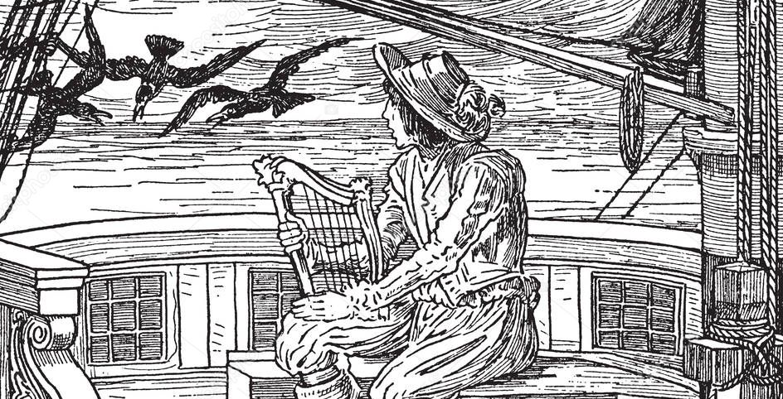
Faithful Johannes Part 2
When they landed, what the raven foretold did indeed happen, and a magnificent chestnut horse sprang forward.
"Excellent!" said the king. "He shall carry me to my castle."
He was about to mount it when faithful Johannes pushed in front of him, quickly jumped onto the horse, drew the gun from its saddlebag, and shot the horse.
The king's other servants, who were not very fond of faithful Johannes, shouted, "How shameful to kill the beautiful animal that was to have carried the king to his castle."
But the king said, "Hold your peace and leave him alone. He is my most faithful Johannes. Who knows what good may come of this?"
They entered the castle, and in the hall there stood a platter on which lay the wedding shirt that appeared to be made of gold and silver. The young king went towards it and was about to take hold of it, but faithful Johannes pushed him away, seized it with gloves, carried it quickly to the fire, and burned it up.
The other servants began to murmur again, saying, "Look, now he is even burning up the king's wedding shirt."
But the young king said, "Who knows what good he may have done? Leave him alone. He is my most faithful Johannes."
And now the wedding took place. The dance began, with the bride also taking part. Faithful Johannes was watchful and looked into her face. Suddenly she turned pale and fell to the ground as if she were dead. He ran quickly to her, picked her up and carried her into a chamber. He laid her down, then knelt and sucked three drops of blood from her right breast, and spat them out. Immediately she breathed again and regained consciousness. The young king saw what had happened, and not knowing why faithful Johannes had done it, grew angry and shouted, "Throw him into prison."
The next morning faithful Johannes was condemned and led to the gallows. Standing high on the platform and about to be executed, he said, "Everyone who is condemned to die is permitted before his end to say one last thing. May I too have this right?"
"Yes," answered the king. "You are granted this right."
Faithful Johannes said, "I have been unjustly condemned, and have always been loyal to you, and he related how he had heard the conversation of the ravens at sea, and how he had had to do all these things in order to save his master.
Then the king cried, "Oh, my most faithful Johannes, pardon! Pardon! Bring him down."
But as faithful Johannes spoke the last word, he fell down lifeless and turned to stone.
This caused the king and the queen great grief, and the king said, "Oh, I have rewarded him very badly for his great loyalty." He then ordered the stone figure to be taken up and placed in his bedroom next to his bed. Every time that he looked at it he wept, saying, "Oh, if only I could bring you back to life again, my most faithful Johannes."
Some time passed and the queen bore twins, two sons who grew fast and were her delight. Once when the queen was at church and the two children were sitting beside their father and playing, he again looked sadly at the stone statue and said, "Oh, if only I could bring you back to life again, my most faithful Johannes."
Then the stone began to speak and said, "You can bring me back to life again if you will in return give up what is dearest to you."
The king cried, "For you I will give up everything I have in the world."
The stone continued, "If you will cut off the heads of your two children with your own hand, then sprinkle their blood on me, I shall be restored to life."
The king was horrified when he heard that he would have to kill his own dearest children, but he thought of faithful Johannes's great loyalty, and how he had died for him, then drew his sword, and with his own hand cut off the children's heads. And when he had smeared the stone with their blood, it returned to life, and faithful Johannes stood before him, again healthy and well.
He said to the king, "Your loyalty shall not go unrewarded," then taking the children's heads, he put them on again, then rubbed the wounds with their blood, at which they became immediately whole again, and jumped about and went on playing as if nothing had happened.
The king was overjoyed. When he saw the queen coming he hid faithful Johannes and the two children in a large chest. When she entered, he said to her, "Have you been praying in the church?"
"Yes, she answered, "but I have constantly been thinking about faithful Johannes and what misfortune has befallen him because of us."
Then he said, "Dear wife, we can give him his life again, but it will cost us our two little sons. We will have to sacrifice them."
The queen turned pale, and her heart filled with terror, but she said, "We owe it to him for his great loyalty."
The king rejoiced to hear that she agreed with him, then he opened up the chest and brought forth faithful Johannes and the children, saying, "God be praised! Faithful Johannes has been saved, and we have our little sons again as well." He told her how everything had happened. Then they lived happily together until they died.

Core Knowledge Lesson 4: Romantic Nationalism - settings
When The Grimms’ Tales were first published in 1812 people across Europe were questioning what it meant to be part of a country. All kinds of people were questioning who they were and why their lives were a certain way. Peasants in the countryside were questioning why they had to be obedient to a Lord they would almost never see, let alone speak to. Factory workers in cities were questioning why they were paid barely enough to buy food while privileged business owners lived in great luxury. The world was a changing place, and new technology and inventions meant cities were being built and old ways of life were dying out. For a long time, society had been binary – if there were rich there had to be poor, if there were strong there had to be weak, if there were privileged there had to be
The Grimm brothers felt this too, and when they collected stories for their book they wanted to help create a new identity for Germany. Their identity would come from history and culture rather than obedience to a King. This is called Romanic Nationalism. Instead of your identity being ‘I am a peasant loyal to a Lord’ it could become ‘I am German and I am part of a great country’. The Grimm brothers saw how certain stories, ideas, characters and settings had special meanings to people in Germany and wanted to put them all together.
We see this in many of the stories they collected. Certain settings had special meanings to Germans and represented bigger ideas. Often these ideas came in pairs, or binaries. The binary of the forest and the castle shows wild nature versus powerful society. Within the the forest you might find a disgusting frog, the binary of a beautiful princess from a castle. These simple binaries made it easy for people to understand the deeper meanings of stories.
privilege (n)  privileged (adj)  privilege (v) | A special right or advantage given to only certain people | Choosing what you wanted to do with your life was a privilege granted to only a few people in the 19th century.
binary (n)  binary (adj) | Something that breaks down into two parts | Male and female are the binary parts of gender.

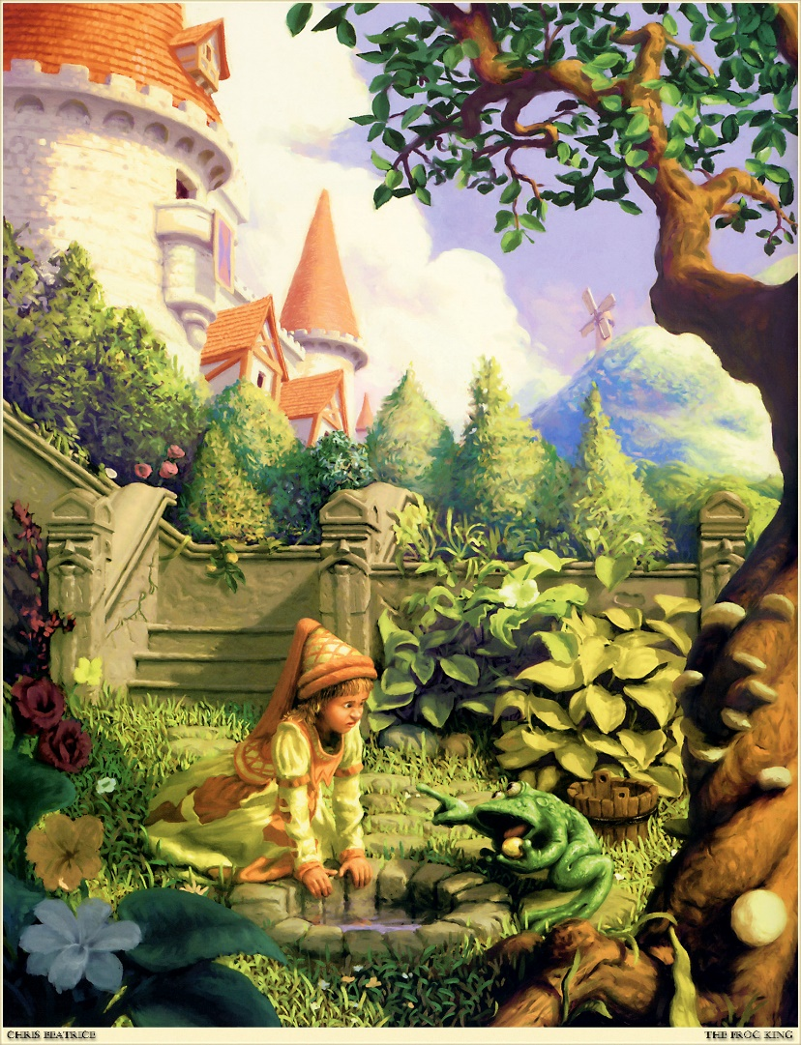
Iron Heinrich Part 1

In the olden days, when wishing still worked, there lived a king whose daughters were all beautiful; but the youngest daughter was so lovely that even the sun, who had seen many things, was struck with wonder every time he shone on her face. Not far away from the king’s palace there was a deep dark forest, and under a lime tree in the forest and sit by the edge of the well, from which a marvellous coolness seemed to flow.
To pass the time she had a golden ball, which she used to throw up in the air and catch. It was her favourite game. Now one day it happened that she threw it a little carelessly, and she couldn’t catch it. Instead the ball rolled away from her and towards the well, and then it ran right over the edge.
The ball disappeared.
The princess ran after it, and looked down into the water; but it was so deep that she couldn’t see the ball. She couldn’t even see the bottom of the well.
She began to cry, and she cried louder and louder, inconsolably. But as she wept and sobbed, someone spoke to her. “What’s the matter, princess? You’re crying so bitterly, you’d move a stone to pity.”
She looked round to see where the voice was coming from, and saw a frog who’d stuck his big ugly head out of the water.
She looked around to see where the voice was coming from and saw a frog, who had stuck his thick, ugly head out of the water. "Oh, it's you, old water-splasher," she said. "I am crying because my golden ball has fallen into the well."
"Be still and stop crying," answered the frog. I can help you, but what will you give me if I bring back your plaything?"
"Whatever you want, dear frog," she said, "my clothes, my pearls and precious stones, and even the golden crown that I am wearing."
The frog answered, "I do not want your clothes, your pearls and precious stones, nor your golden crown, but if you will love me and accept me as a companion and playmate, and let me sit next to you at your table and eat from your golden plate and drink from your cup and sleep in your bed, if you will promise this to me, then I'll dive down and bring your golden ball back to you."
"Oh, yes," she said, "I promise all of that to you if you will just bring the ball back to me." But she thought, "What is this stupid frog trying to say? He just sits here in the water with his own kind and croaks. He cannot be a companion to a human."
As soon as the frog heard her say "yes" he stuck his head under and dove to the bottom. He paddled back up a short time later with the golden ball in his mouth and threw it onto the grass. The princess was filled with joy when she saw her beautiful plaything once again, picked it up, and ran off.
Core Knowledge Lesson 5: Romantic Nationalism - characters
Last lesson we learned about how people in the 19th century were beginning to question their identities and positions in society. For hundreds of years identity had been something innate that you were born with, rather than being something you created for yourself. For example, your value as a human was determined by your position in society rather than how kind, intelligent or strong you were – in other words, a bad noble was worth more than a good peasant.
This dominance of one group of people over another is called a hierarchy. This hierarchy was stable because German society was a hegemony. Germany had been a hierarchy for so long that people were totally unquestioning about their positions. It was unthinkable that a peasant would ever want to become a noble – this was simply an impossible dream. It was a nice idea but no more likely to happen than learning how to fly. Peasants were binary to because they were totally reliant on each other. Without the nobles, the peasants would have no job, no money and no food. Without the peasants the nobles would have no one to work on their land. One couldn’t exist without the other - they had to accept their position in society or risk devastation.
This hegemonic society is seen throughout German fairy tales. In Greek myths those who disobeyed had to be punished by someone higher up such as Zeus punishing Prometheus. However, in Germany’s hegemonic society the idea of peasants being controlled was so innate that peasants would control themselves and maintain order. Fairy tales taught people their positions in society and showed just how innate the hierarchy was to their lives.
innate (adj)  innately (adv) | Something about you that is part of you from birth. | In the Divine Order your position is innate – if your parents are peasants, you are innately a peasant too.
hegemony (n)  hegemonic (adj) | A system in which one group of people have dominance. | The educated middle class had a hegemony of knowledge and culture over the uneducated working class.

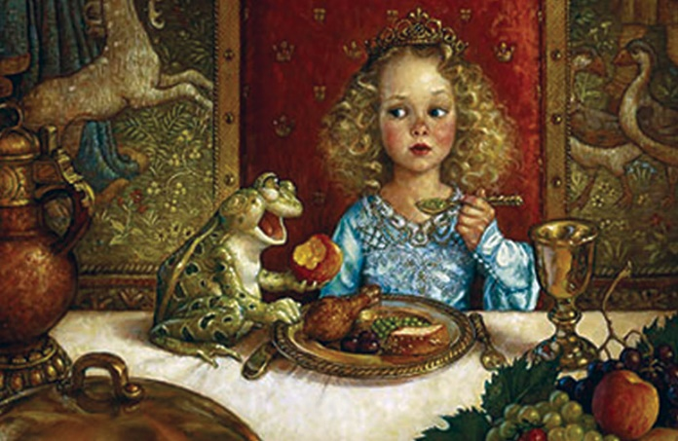
Iron Heinrich Part 2
"Wait, wait," called the frog, "take me along. I cannot run as fast as you." But what did it help him, that he croaked out after her as loudly as he could? She paid no attention to him, but instead hurried home and soon forgot the poor frog, who had to return again to his well.
The next day the princess was sitting at the table with the king and all the people of the court, and was eating from her golden plate when something came creeping up the marble steps: plip, plop, plip, plop. As soon as it reached the top, there came a knock at the door, and a voice called out, "Princess, youngest, open the door for me!"
She ran to see who was outside. She opened the door, and the frog was sitting there. Frightened, she slammed the door shut and returned to the table. The king saw that her heart was pounding and asked, "My child, why are you afraid? Is there a giant outside the door who wants to get you?"
"Oh, no," she answered. "it is a disgusting frog."
"What does the frog want from you?"
"Oh, father dear, yesterday when I was sitting near the well in the forest and playing, my golden ball fell into the water. And because I was crying so much, the frog brought it back, and because he insisted, I promised him that he could be my companion, but I didn't think that he could leave his water. But now he is just outside the door and wants to come in."
Just then there came a second knock at the door, and a voice called out:
Youngest daughter of the king,
Open up the door for me,
Don't you know what yesterday,
You said to me down by the well?
Youngest daughter of the king,
Open up the door for me.
The king said, "What you have promised, you must keep. Go and let the frog in."
She went and opened the door, and the frog hopped in, then followed her up to her chair. He sat there and called out, "Lift me up next to you."
She hesitated, until finally the king commanded her to do it. When the frog was seated next to her he said, "Now push your golden plate closer, so we can eat together."
She did it, but one could see that she did not want to. The frog enjoyed his meal, but for her every bite stuck in her throat. Finally he said, "I have eaten all I want and am tired. Now carry me to your room and make your bed so that we can go to sleep."
The princess began to cry and was afraid of the cold frog and did not dare to even touch him, and yet he was supposed to sleep in her beautiful, clean bed.
The king became angry and said, "You should not despise someone who has helped you in time of need."
She picked him up with two fingers, carried him upstairs, and set him in a corner. As she was lying in bed, he came creeping up to her and said, "I am tired, and I want to sleep as well as you do. Pick me up or I'll tell your father."
With that she became bitterly angry and threw him against the wall with all her might. "Now you will have your peace, you disgusting frog!"
But when he fell down, he was not a frog, but a prince with beautiful friendly eyes. And he was now, according to her father's will, her dear companion and husband. He told her how he had been enchanted by a wicked witch, and that she alone could have rescued him from the well, and that tomorrow they would go together to his kingdom. Then they fell asleep.
The next morning, just as the sun was waking them, a carriage pulled up, drawn by eight horses. They had white ostrich feathers on their heads and were outfitted with chains of gold. At the rear stood the young king's servant, faithful Heinrich. Faithful Heinrich had been so saddened by his master's transformation into a frog that he had had to place three iron bands around his heart to keep it from bursting in grief and sorrow. The carriage was to take the king back to his kingdom. Faithful Heinrich lifted them both inside and took his place at the rear. He was filled with joy over the redemption. After they had gone a short distance, the prince heard a crack from behind, as though something had broken.
He turned around and said, "Heinrich, the carriage is breaking apart."
No, my lord, the carriage it's not, but one of the bands surrounding my heart,
That suffered such great pain, when you were sitting in the well,
When you were a frog.
Once again, and then once again the prince heard a cracking sound and thought that the carriage was breaking apart, but it was the bands springing from faithful Heinrich's heart because his master was now redeemed and happy.
gendered (adj)  gendering (v) | Relating to one particular gender. | Certain attributes have traditionally been gendered – strength was male, kindness was female.
passive (adj) | Accepting or allowing what happens without resistance. | The working class had to be passive because they were reliant on the middle and upper class.
active (adj) | Participating or taking part in something. | The Grimm brothers were active in the creation of a new identity for Germany.
reliance (n)  reliant (adj)  rely (v) | Needing something or someone else. | The working class were reliant on higher classes for jobs.
Core Knowledge Lesson 7: 19th Century Patriarchy
Before the 19th century (1800-1900) many areas of Germany had families living in a “whole house” system. In this system, many families would live together in one large building owned by one rich family, sort of like lots of houses connected together sharing one big kitchen. The rich and poor were reliant on each other. The poorer families were employed by the rich family to work on their land or create textiles and other goods. The wife in the rich family was in charge of all the women from the other families and the women worked closely together to run and organise the families while men did physical work.
This changed in the 19th century because the way farms were run changed with the Industrial Revolution. Now instead of rich and poor families living and working together under one roof, each family was separated into their own houses.
The poorer families had to look after themselves completely. Families began to value privacy and self-preservation rather than sharing, and although the husband was in charge, the wife became seen as the main figure of the German family. She was expected to support and care for the entire family and make important decisions about spending money and looking after the house. Just like before, German women were not really allowed to make decisions about what they would do with their lives, but now a lot more was being asked of them. They had to be passive to their husbands when asked to do something, but active in making decisions about looking after the family. The roles of the family were heavily gendered – boys would work, girls would clean and cook.
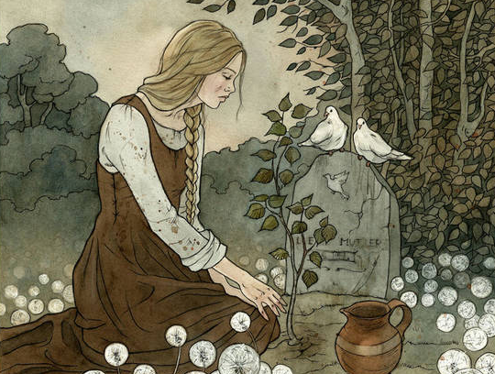
Cinderella Part 1
A rich man's wife became sick, and when she felt that her end was drawing near, she called her only daughter to her bedside and said, "Dear child, remain pious and good, and then our dear God will always protect you, and I will look down on you from heaven and be near you." With this she closed her eyes and died.
The girl went out to her mother's grave every day and wept, and she remained pious and good. When winter came the snow spread a white cloth over the grave, and when the spring sun had removed it again, the man took himself another wife.
This wife brought two daughters into the house with her. They were beautiful, with fair faces, but evil and dark hearts. Times soon grew very bad for the poor stepchild.
"Why should that stupid goose sit in the parlor with us?" they said. "If she wants to eat bread, then she will have to earn it. Out with this kitchen maid!"
They took her beautiful clothes away from her, dressed her in an old gray smock, and gave her wooden shoes. "Just look at the proud princess! How decked out she is!" they shouted and laughed as they led her into the kitchen.
There she had to do hard work from morning until evening, get up before daybreak, carry water, make the fires, cook, and wash. Besides this, the sisters did everything imaginable to hurt her. They made fun of her, scattered peas and lentils into the ashes for her, so that she had to sit and pick them out again. In the evening when she had worked herself weary, there was no bed for her. Instead she had to sleep by the hearth in the ashes. And because she always looked dusty and dirty, they called her Cinderella.
One day it happened that the father was going to the fair, and he asked his two stepdaughters what he should bring back for them.
"Beautiful dresses," said the one.
"Pearls and jewels," said the other.
"And you, Cinderella," he said, "what do you want?"
"Father, break off for me the first twig that brushes against your hat on your way home."
So he bought beautiful dresses, pearls, and jewels for his two stepdaughters. On his way home, as he was riding through a green thicket, a hazel twig brushed against him and knocked off his hat. Then he broke off the twig and took it with him. Arriving home, he gave his stepdaughters the things that they had asked for, and he gave Cinderella the twig from the hazel bush.
Cinderella thanked him, went to her mother's grave, and planted the branch on it, and she wept so much that her tears fell upon it and watered it. It grew and became a beautiful tree.
Cinderella went to this tree three times every day, and beneath it she wept and prayed. A white bird came to the tree every time, and whenever she expressed a wish, the bird would throw down to her what she had wished for.
Now it happened that the king proclaimed a festival that was to last three days. All the beautiful young girls in the land were invited, so that his son could select a bride for himself. When the two stepsisters heard that they too had been invited, they were in high spirits.
They called Cinderella, saying, "Comb our hair for us. Brush our shoes and fasten our buckles. We are going to the festival at the king's castle."
Cinderella obeyed, but wept, because she too would have liked to go to the dance with them. She begged her stepmother to allow her to go.
"You, Cinderella?" she said. "You, all covered with dust and dirt, and you want to go to the festival?. You have neither clothes nor shoes, and yet you want to dance!"
However, because Cinderella kept asking, the stepmother finally said, "I have scattered a bowl of lentils into the ashes for you. If you can pick them out again in two hours, then you may go with us."
The girl went through the back door into the garden, and called out:
Turtledoves and little pigeons,
All the birds beneath the sky,
Help me pick the lentils out
From the ashes where they lie!
All the good ones in the pot,
All the others in your crop.

Two white pigeons came in through the kitchen window, and then the turtledoves, and finally all the birds beneath the sky came whirring and swarming in, and lit around the ashes. The pigeons nodded their heads and began to pick, pick, pick, pick. And the others also began to pick, pick, pick, pick. They gathered all the good grains into the bowl. Hardly one hour had passed before they were finished, and they all flew out again.
The girl took the bowl to her stepmother, and was happy, thinking that now she would be allowed to go to the festival with them.
But the stepmother said, "No, Cinderella, you have no clothes, and you don't know how to dance. Everyone would only laugh at you."
Cinderella began to cry, and then the stepmother said, "You may go if you are able to pick two bowls of lentils out of the ashes for me in one hour," thinking to herself, "She will never be able to do that."
The girl went through the back door into the garden, and called out:
Birds of the air, whatever you be,
Come to the shade of the hazel tree!
And in the ashes peck about,
And help me sort the lentils out.
All the good ones in the pot,
All the others in your crop.
Two white pigeons came in through the kitchen window, and then the turtledoves, and finally all the birds beneath the sky came whirring and swarming in, and lit around the ashes. The pigeons nodded their heads and began to pick, pick, pick, pick. And the others also began to pick, pick, pick, pick. They gathered all the good grains into the bowls. Before a half hour had passed they were finished, and they all flew out again.
The girl took the bowls to her stepmother, and was happy, thinking that now she would be allowed to go to the festival with them.
But the stepmother said, "It's no use. You are not coming with us, for you have no clothes, and you don't know how to dance. We would be ashamed of you." With this she turned her back on Cinderella, and hurried away with her two proud daughters, leaving Cinderella on her own.
Core Knowledge Lesson 8: Social Etiquette for children
Today fairy tales still feed our imaginations, providing enchanted forests filled with sleeping beauties, cunning wolves and charming princes. They may take place in magical kingdoms far removed from our own but these stories teach us important life lessons and when the Grimm brothers collected the stories that they are famous for today, a key focus for them was their message to children.
In those days, there was no television, radio or internet, instead people gathered together in the evenings to hear storytellers tell tales like Cinderella. Therefore, it was these stories that taught children important lessons about etiquette and were a deterrent against bad behaviour because they warned children of the dangers of negative behaviour. In a world where many adults believed in witches, demons and magic, it’s easy to imagine how terrifying the idea of being cursed by a witch for not cleaning your bedroom or being locked in a dungeon for not obeying your elders might be to a vulnerable child!
Children were and still are expected to be honest, polite, hard-working and kind. Additionally, children are expected to obey their parents and elders. Fairy tales promise children that if they meet these expectations then they will live positive and happy lives, but if they don’t then they will be severely punished. This is all part of the natural order – the way most 19th century Europeans believed things were meant to be, as decided by God.
etiquette (n) | Rules for polite behaviour. | In the 19th century, there were clear rules of etiquette for children.
deterrent (n)  deter (v) | Something negative that discourages someone from doing something. | Fairy tales focused heavily on the consequences of bad or dishonest behaviour so they could deter children from behaving poorly.

Cinderella Part 2
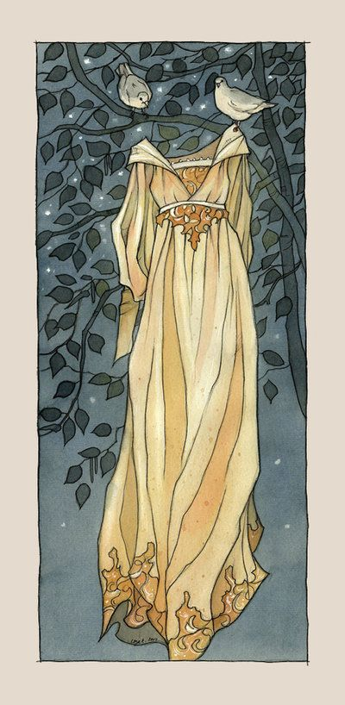
First, Cinderella washed herself from head to toe and brushed her hair till not a speck of ash and soot remained. Then she went to her mother's grave beneath the hazel tree, and cried out:
Hazel tree, be kind to me!
Shake your leaves and set me free!
I’m very poor, and I confess
I’d love to wear a pretty dress.
Then the bird threw a gold and silver dress down to her, and slippers embroidered with silk and silver. She quickly put on the dress and went to the festival.
Her stepsisters and her stepmother did not recognize her. They thought she must be a foreign princess, for she looked so beautiful in the golden dress. They never once thought it was Cinderella, for they thought that she was sitting at home in the dirt, looking for lentils in the ashes.
The prince approached her, took her by the hand, and danced with her. Furthermore, he would dance with no one else. He never let go of her hand, and whenever anyone else came and asked her to dance, he would say, "She is my dance partner."
She danced until evening, and then she wanted to go home. But the prince said, "I will go along and escort you," for he wanted to see to whom the beautiful girl belonged. However, she eluded him and jumped into the pigeon coop. The prince waited until her father came, and then he told him that the unknown girl had jumped into the pigeon coop.
The old man thought, "Could it be Cinderella?"
He had them bring him an axe and a pick so that he could break the pigeon coop apart, but no one was inside. When they got home Cinderella was lying in the ashes, dressed in her dirty clothes. A dim little oil-lamp was burning in the fireplace. Cinderella had quickly jumped down from the back of the pigeon coop and had run to the hazel tree. There she had taken off her beautiful clothes and laid them on the grave, and the bird had taken them away again. Then, dressed in her grey smock, she had returned to the ashes in the kitchen.
The next day when the festival began anew, and her parents and her stepsisters had gone again, Cinderella went to the hazel tree and said:
Hazel tree, oh, hazel tree,
Shake your leaves again for me!
Help me out in my distress,
And let me have another dress!
Then the bird threw down an even more magnificent dress than on the preceding day. When Cinderella appeared at the festival in this dress, everyone was astonished at her beauty. The prince had waited until she came, then immediately took her by the hand, and danced only with her. When others came and asked her to dance with them, he said, "She is my dance partner."
When evening came she wanted to leave, and the prince followed her, wanting to see into which house she went. But she ran away from him and into the garden behind the house. A beautiful tall tree stood there, on which hung the most magnificent pears. She climbed as nimbly as a squirrel into the branches, and the prince did not know where she had gone. He waited until her father came, then said to him, "The unknown girl has eluded me, and I believe she has climbed up the pear tree.
The father thought, "Could it be Cinderella?" He had an axe brought to him and cut down the tree, but no one was in it. When they came to the kitchen, Cinderella was lying there in the ashes as usual, for she had jumped down from the other side of the tree, had taken the beautiful dress back to the bird in the hazel tree, and had put on her grey smock.
On the third day, when her parents and sisters had gone away, Cinderella went again to her mother's grave and said to the tree:
Hazel tree, oh, hazel tree,
Send another dress for me!
This is the last night of the ball,
So let it be the best of all!
This time the bird threw down to her a dress that was more splendid and magnificent than any she had yet had, and the slippers were of pure gold. When she arrived at the festival in this dress, everyone was so astonished that they did not know what to say. The prince danced only with her, and whenever anyone else asked her to dance, he would say, "She is my dance partner."
When evening came Cinderella wanted to leave, and the prince tried to escort her, but she ran away from him so quickly that he could not follow her. The prince, however, had set a trap. He had had the entire stairway smeared with pitch. When she ran down the stairs, her left slipper stuck in the pitch. The prince picked it up. It was small and dainty, and of pure gold.
The next morning, he went with it to the man, and said to him, "No one shall be my wife except for the one whose foot fits this golden shoe."
The two sisters were happy to hear this, for they had pretty feet. With her mother standing by, the older one took the shoe into her bedroom to try it on. She could not get her big toe into it, for the shoe was too small for her. Then her mother gave her a knife and said, "Cut off your toe. When you are queen you will no longer have to go on foot."
The girl cut off her toe, forced her foot into the shoe, swallowed the pain, and went out to the prince. He took her on his horse as his bride and rode away with her. However, they had to ride past the grave, and there, on the hazel tree, sat the two pigeons, crying out:
Rook di goo, rook di goo!
There's blood in the shoe.
The shoe is too tight,
This bride is not right!
Then he looked at her foot and saw how the blood was running from it. He turned his horse around and took the false bride home again, saying that she was not the right one, and that the other sister should try on the shoe. She went into her bedroom, and got her toes into the shoe all right, but her heel was too large.
Then her mother gave her a knife, and said, "Cut a piece off your heel. When you are queen you will no longer have to go on foot."
The girl cut a piece off her heel, forced her foot into the shoe, swallowed the pain, and went out to the prince. He took her on his horse as his bride and rode away with her. When they passed the hazel tree, the two pigeons were sitting in it, and they cried out:
Rook di goo, rook di goo!
There's blood in the shoe.
The shoe is too tight,
This bride is not right!
He looked down at her foot and saw how the blood was running out of her shoe, and how it had stained her white stocking all red. Then he turned his horse around and took the false bride home again.
"This is not the right one, either," he said. "Don't you have another daughter?"
"No," said the man. "There is only a deformed little Cinderella from my first wife, but she cannot possibly be the bride."
The prince told him to send her to him, but the mother answered, "Oh, no, she is much too dirty. She cannot be seen."
But the prince insisted on it, and they had to call Cinderella. She first washed her hands and face clean, and then went and bowed down before the prince, who gave her the golden shoe. She sat down on a stool, pulled her foot out of the heavy wooden shoe, and put it into the slipper, and it fitted her perfectly.
When she stood up the prince looked into her face, and he recognized the beautiful girl who had danced with him. He cried out, "She is my true bride."
The stepmother and the two sisters were horrified and turned pale with anger. The prince, however, took Cinderella onto his horse and rode away with her. As they passed by the hazel tree, the two white pigeons cried out:
Rook di goo, rook di goo!
No blood's in the shoe.
The shoe's not too tight,
This bride is right!
After they had cried this out, they both flew down and lit on Cinderella's shoulders, one on the right, the other on the left, and remained sitting there.
When the wedding with the prince was to be held, the two false sisters came to share in Cinderella’s good fortune. When the bridal couple walked into the church, the older sister walked on their right side and the younger on their left side, and the pigeons pecked out one eye from each of them. Afterwards, as they came out of the church, the older one was on the left side, and the younger one on the right side, and then the pigeons pecked out the other eye from each of them. And thus, for their wickedness and falsehood, they were punished with blindness as long as they lived.

Core Knowledge Lesson 10: The Idyllic German Matriarch
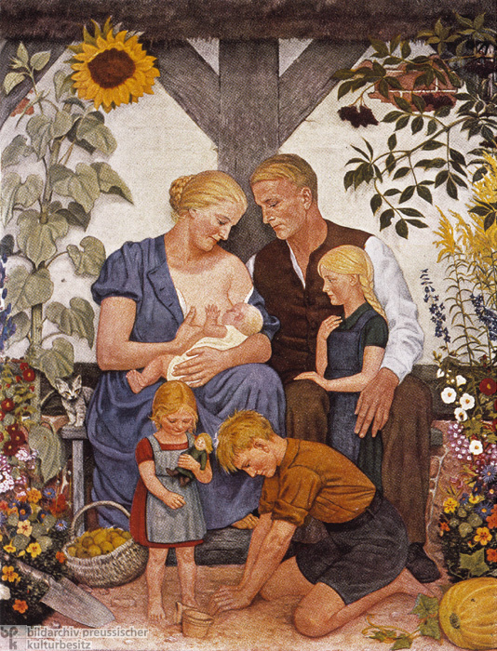
Previously, we learned about how in rural areas many families might live in one house where one family was in charge. However, this changed in the 19th century as families began to become more independent and lived apart. At the same time, as a result of these changes to the way people lived, people were having far fewer children. This meant parents had time for much greater attention to each child.
This painting was done in 1930s Germany to show the perfect German family The ideas are based on German tradition.
The mother is the centre of the family and the rest of the family gather around her. The setting shows that the family live close to nature, probably on a farm based on the tools and gathered fruit at the bottom left. The son seems to be planting a seed while his little sister holds a doll.
This image sums up ideas about the idyllic German Matriarch – she was the strength of not just the family, but the nation because she help up the family.
matriarch (n)  matriarchal (adj) | A woman who is the head of a family or organisation. | The German matriarch was critical to keeping the family running.
idyll (n)  idyllic (adj) | An extremely peaceful or perfect situation, often unrealistic or unsustainable. | The perfect German family was an idyllic one – peaceful and strong, but this was often impossible.

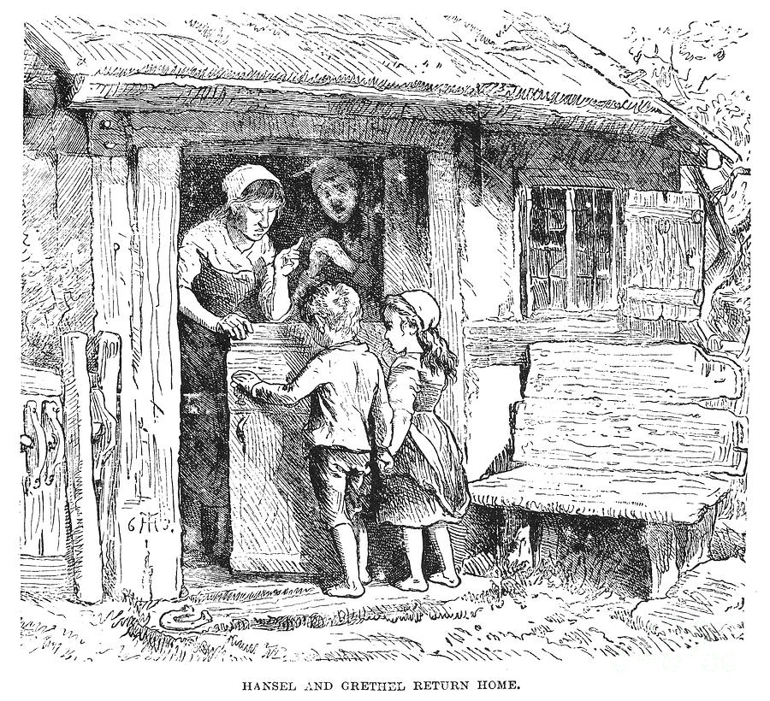
Hansel and Gretel Part 1
Next to a great forest there lived a poor woodcutter with his wife and his two children. The boy's name was Hansel and the girl's name was Gretel. He had but little to eat, and once, when a great famine came to the land, he could no longer provide even their daily bread. One evening as he was lying in bed worrying about his problems, he sighed and said to his wife, "What is to become of us? How can we feed our children when we have nothing for ourselves?"
"I’ll tell you what,” she said. “This is what we’ll do. Early tomorrow morning we will take the two children out into the thickest part of the woods, make them comfortable, light a fire for them, and give each of them a little piece of bread, then leave them by themselves and go off to our work. They will not find their way back home, and we will be rid of them."
"No, no, no,” said the husband, “I won’t do that. How could I bring myself to abandon my own children alone in the woods? Wild animals would soon come and tear them to pieces."
"Oh, you fool," she said, "then all four of us will starve. You may as well start planting the wood for our coffins." And she gave him no peace until he agreed.
In the next room, the children were awake. They couldn’t sleep because they were so hungry, and they had heard every word their stepmother said to the father. Gretel cried bitter tears and said to Hansel, "It is over with us!"
"Hush, Gretel," said Hansel, "Stop worrying. I know what we can do."
And as soon as the adults had fallen asleep, he got up, pulled on his jacket, opened the lower door, and crept outside. The moon was shining brightly, and the white pebbles in front of the house were glistening like silver coins. Hansel bent over and filled his jacket pockets with them, as many as would fit. Then he went back into the house and said, "Don't worry, Gretel. Sleep well. God will not forsake us." Then he went back to bed.
At daybreak, even before sunrise, the woman came and woke the two children. "Get up, you lazybones. We are going into the woods to fetch wood." Then she gave each one a little piece of bread, saying, "Here is something for midday. Don't eat it any sooner, for you'll not get any more."
Then all together they set forth into the woods. After they had walked a little way, Hansel began stopping again and again and looking back toward the house.
The father said, "Hansel, why are you stopping and looking back? Pay attention now, and don't forget your legs."
"Oh, father," said Hansel, "I am looking at my white cat that is sitting on the roof and wants to say good-bye to me."
The woman said, "You fool, that isn't your cat. That's the morning sun shining on the chimney."
However, Hansel had not been looking at his cat but instead had been dropping the shiny pebbles from his pocket onto the path.
When they arrived in the middle of the woods, Hansel and Gretel gathered together some twigs, a pile as high as a small mountain. The twigs were set afire, and when the flames were burning well, the woman said, "Lie down by the fire and rest. We will go into the woods to cut wood. When we are finished, we will come back and get you."
Hansel and Gretel sat by the fire. When midday came each one ate his little piece of bread. Because they could hear the blows of an axe, they thought that the father was nearby. However, it was not an axe. It was a branch that he had tied to a dead tree and that the wind was beating back and forth. After they had sat there a long time, their eyes grew weary and closed, and they fell sound sleep. When they finally awoke, it was dark at night. Gretel began to cry and Hansel comforted her, "Wait a little until the moon comes up, and then we'll find the way out of here."
After the full moon had come up, Hansel took his little sister by the hand. They followed the pebbles that glistened there like newly minted coins, showing them the way. They walked throughout the entire night, and as morning was breaking, they arrived at the father's house.
The door was locked, so they knocked loudly. When the woman opened it her eyes opened too, in shock. “You wretched children! You made us so worried!” And she hugged them so tightly they couldn’t breathe. “Why did you sleep so long? We thought you didn’t want to come back!”
And she pinched their cheeks as if she were really glad to see them. When their father came down a moment later, the relief and joy in his face was real, because he hadn’t wanted to leave them at all.
So that time they were safe. But not long afterwards, food was short again, and many people went hungry. One night the children heard the woman say to their father, “It’s no good. We’ve only got half a loaf left, and then we’ll all starve. We must get rid of the children, and do it properly this time. They must have had some trick before, but if we take them deep enough into the woods they’ll never find their way out.”
“Oh, I don’t like it,” said the father. “There’s not just wild animals in the forest, you know. There are goblins and witches and the Lord knows what. Wouldn’t it be better to share the loaf with the children?”
“Don’t be stupid,” said the woman. “Where’s the sense in that? You’re soft, that’s the trouble with you. Soft and stupid.”
She tore him to shreds with her criticism, and he had no defence; if you’ve given in once, you have to give in forever after.
The children were still awake and had overheard the conversation. When the adults were asleep, Hansel got up again and wanted to gather pebbles as he had done before, but the woman had locked the door, and Hansel could not get out. But he comforted his little sister and said, "Don't cry, Gretel. Sleep well. God will help us."
Early the next morning the woman came and woke the children as she’d done before, and gave them each a piece of bread, though it was even smaller this time. As they went into the forest, Hansel crumbled his bread up and dropped his crumbs on the path, stopping every so often to make sure he could see them.
“Hansel, keep going,” said his father. “Stop looking back all the time.”
"I can see my pigeon sitting on the roof. It wants to say good-bye to me."
"Fool," said the woman, "that isn't your pigeon. That's the morning sun shining on the chimney. Stop dawdling."
But little by little Hansel dropped all the crumbs onto the path. The woman took them deeper into the woods than they had ever been in their whole lifetime. Then, again a large fire was made, and the step mother said, "Sit here, children. If you get tired you can sleep a little. We are going into the woods to cut wood. We will come and get you in the evening when we are finished."
When it was midday, Gretel shared her bread with Hansel, who had scattered his piece along the path. Then they fell asleep, and evening passed, but no one came to get the poor children.
It was dark at night when they awoke, and Hansel comforted Gretel and said, "Wait, when the moon comes up I will be able to see the crumbs of bread that I scattered, and they will show us the way back home."
Core Knowledge Lesson 11: The importance of families in Industrial Europe
During the time of the Grimm brothers in the 19th century, almost all people in European countries relied on family based production and work to make money and survive. Children worked and helped their parents in the running of the household and farming. Most working class children wouldn’t go to school or learn to read and write – as soon as you were old enough to work a field, bake bread or do other physical jobs, then you would be helping your family to earn a living. In a time when food supplies were short and the majority of people lacked money and job opportunities, a hard working family from the children to the grandparents became the most important aspect of survival and ability to triumph against poverty and starvation.
Families worked together, farmed food together and sold their products and goods together at markets. However, with the invention of industrial machines some families lost the farms or land they once worked on, and so instead of being able to work together and view their children as helpful, the children of these families were viewed as burdens by their parents. Poor parents struggled to feed their children and became so desperate that they might abandon their children so they wouldn’t have to watch them die, this made children even more vulnerable in an already difficult and dangerous time. The tale of Hansel and Gretel explores these ideas heavily, by focusing on the desperation of the parents and the manipulation of the witch, using the hunger of the children against them.
vulnerability (n)  vulnerable (adj) | - Sensitive to the possibility of being harmed, either physically or emotionally. | In the 19th century, poor families with many children were vulnerable to starvation.
triumph (n)  triumphant (adj)  triumph (v) | A great victory or achievement. | Families that worked as a team had greater chance of triumph against poverty.

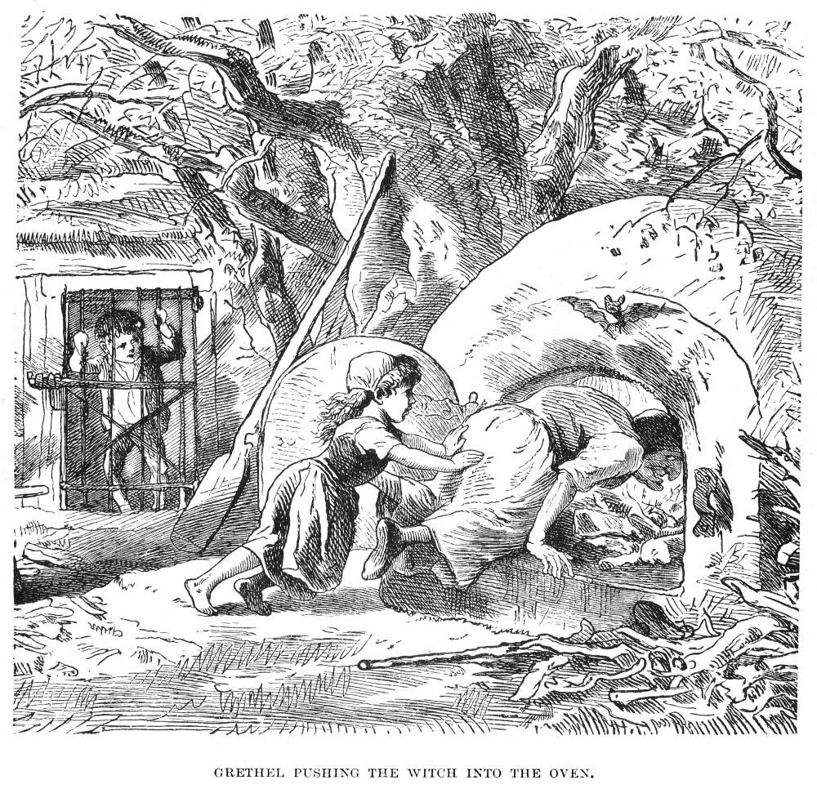
Hansel and Gretel Part 2
When the moon appeared they got up, but they could not find any crumbs, for the many thousands of birds that fly about in the woods and in the fields had pecked them up. So, they walked all through the night and then all through the following day, and still they were lost. They were hungry, too, terribly hungry, because all they’d had to eat were a few berries that they’d found. They lay down under a tree and fell asleep. If help did not come soon, they would perish. At midday on the third day they saw a little snow-white bird sitting on a branch. It sang so beautifully that they stopped to listen. When it was finished it stretched its wings and flew in front of them, moving no faster than they could walk, so that it really seemed to be guiding them.
And all of a sudden they found themselves in front of a little house. The bird perched on the roof, and there was something strange about the look of that roof. In fact – “It’s made of cake!” said Hansel.
And as for the walls – “They’re made of bread!” said Gretel.
And as for the windows, they were made of sugar. The poor children were so hungry that they didn’t even think of knocking at the door and asking permission. Hansel broke off a piece of the roof, and Gretel knocked through a window, and they sat down right where they were and started to eat at once. After a good few mouthfuls, they heard a soft voice from inside:
Nibble, nibble, little mouse,
Who is nibbling at my house?
The children answered:
The wind, so wild,
The heavenly child.
And they went on eating, they were so ravenous. Hansel liked the taste of the roof so much that he pulled off a piece as long as his arm, and Gretel carefully pushed out another windowpane and started crunching her way through it. Suddenly the door opened and an old, old woman came hobbling out. Hansel and Gretel were so surprised that they stopped eating and stared at her with their mouths full.
But the old woman shook her head and said, “Don’t be frightened, my little dears! Who brought you here? Just come inside, my darlings, come and rest your poor selves in my little box of treats. No harm will come to you." She pinched them by the cheeks fondly, and took each of them by the hand and led them into the cottage. As if she’d known they were coming, there was a table laid with two places, and she served them a delicious meal of milk and pancakes with sugar and spices, and apples and nuts.
Afterward she showed them into a little bedroom where two beds were made up ready, with snow-white sheets. Hansel and Gretel went to bed, thinking they were in heaven, and fell asleep at once. But the old woman had only pretended to be friendly. In fact, she was a wicked witch who was lying in wait there for children. She had built her house of bread only in order to lure them to her, and if she captured one, she would kill him, cook him, and eat him; and for her that was a day to celebrate. Witches have red eyes and cannot see very far, but they have sense of smell like animals, and know when humans are approaching.
Early the next morning, before they awoke, the witch got up, went to their beds, and looked at the two of them lying there so peacefully, with their full red cheeks. "They will be a good mouthful," she mumbled to herself. Then she grabbed Hansel with her withered hand and carried him to a little stall, where she locked him behind a cage door. He cried then all right, but there was no one to hear.
Then she shook Gretel awake and cried, "Get up, lazybones! Fetch water and cook something good for your brother. He is locked outside in the stall and is to be fattened up. When he is fat enough, I am going to eat him."
Gretel began to cry, but it was all for nothing. She had to do what the witch demanded. Now Hansel was given the best things to eat every day, but Gretel received nothing but crayfish shells. Every morning the old woman crept out to the stall and shouted, "Hansel, stick out your finger, so I can feel if you are fat yet."
But Hansel stuck out a little bone, and the old woman, who had bad eyes and could not see the bone, thought it was Hansel's finger, and she wondered why he didn't get fat.
When four weeks had passed and Hansel was still thin, impatience overcame her, and she would wait no longer. "Hey, Gretel!" she shouted to the girl, "Hurry up and fetch some water. Whether Hansel is fat or thin, tomorrow I am going to slaughter him and boil him up for a stew. First we are going to bake. I have already made a fire in the oven and kneaded the dough."
She opened the oven from which fiery flames were leaping, spitting and flaring. "Climb in," said the witch, "and see if it is hot enough to put the bread in yet." And when Gretel was inside, she intended to close the oven, and bake her, and eat her as well. But Gretel saw what she had in mind, so she said, "I don't quite understand. You want me to get inside? How can I do that?"
"Stupid goose," said the old woman. The opening is big enough. See, I myself could get in." And she crawled up stuck her head into the oven.
As soon as she did, Gretel shoved her so hard that she overbalanced and fell in. Gretel closed the door at once and secured it with an iron bar. Horrible shrieks and screams and howls came from the oven and Gretel closed her ears and ran outside. The witch burned to death. And Gretel ran straight to the shed and cried: “Hansel, we’re safe! The old witch is dead!”
Then Hansel jumped out, like a bird from its cage when someone opens its door. How happy they were! They threw their arms around each other's necks and jumped with joy. Now they had nothing to fear, they went into the witch's house and in every corner were chests of pearls and precious stones.
The man had not had even one happy hour since he had left the children in the woods. Not long after that, his wife had died, and he was all alone, and poorer than ever. But now Gretel unfolded her little apron and shook out all the jewels so that they bounced and scattered all over the room, and Hansel threw handful after handful after them.
So all their troubles were over, and they lived happily ever after."
Core Knowledge Lesson 13: German restoration of Absolutism
Germany wasn’t always one country. Until 1871, it was split into many smaller nations such as Hanover, Prussia and Bavaria. During the 1800s Germany was an area full of dispute and war. The old ways of living were falling apart as the world became more modern, and the way Germany would look in a modern world was not predictable. The working class wanted more freedom and better lives, but the old rulers wanted to hold on to power.
For example, in 1837, King Ernst of Hanover (a German state) tried to undo many of the changes to new laws that had taken power away from the ruling and upper classes and handed it to the middle and working classes. He wanted to bring back absolutism for the Kingdom of Hannover. Absolutism is a type of monarchy where the King or Queen has total power and control – there are no rules or laws they have to follow. This is different to England’s constitutional monarchy of today – our Queen cannot just kill someone or start a war when she feels like it!
At this time, the Grimm brothers lived in Hanover and were expected to take an oath of allegiance (a promise that they would obey the King completely). However, they took part in a protest against this – a decision that could have led to them being killed. To escape the danger, Jacob left Hanover immediately and Wilhelm followed him a few months later.
The brothers clearly didn’t think the King should be allowed to do whatever he wanted. They believed that there was a natural order to things decided by God, and this idea is often recurrent in the stories they chose to include in their book. People in their stories rarely get away with breaking rules or acting in an evil way; they are almost always punished by people around them or by nature. The way people are expected to behave is determined.
predictable (adj)  predict (v) | Easy to tell what will happen next. | The result of disobeying a King is predictable – punishment!
recurrent (adj)  recur (v) | One idea appearing again and again. | The idea that one person cannot control the way things are is recurrent in the Grimms’ tales.
determinism (n)  determinist (adj)  determine (v) | The idea that our lives are not controlled by our own actions, but by things that happen to us. | In fairy tales a character might try to take control, but nature will normally restore order in the end.

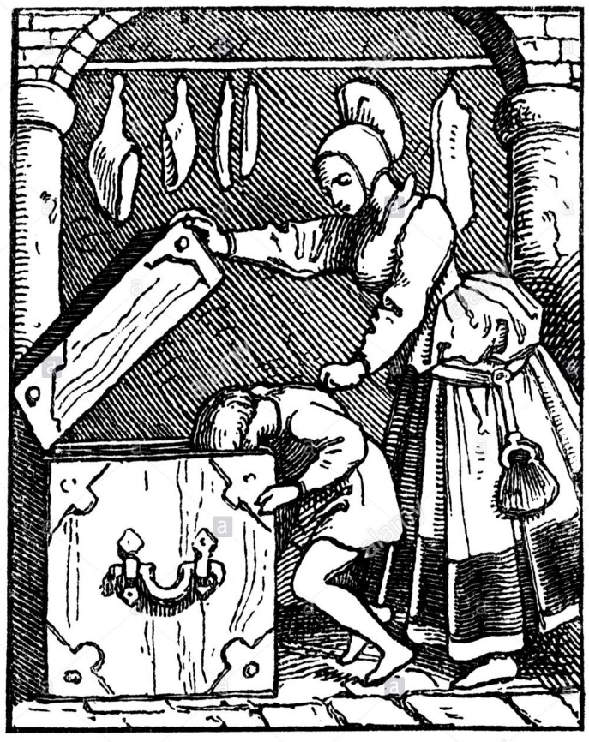
The Juniper Tree Part 1
Long ago, there was a rich man who had a good and beautiful wife, and they loved each other dearly. There was only one thing missing, and that was children, but although they longed and prayed for a child, no child came, and no child came.
Now in front of their house there stood a juniper tree. One winter day the woman was standing beneath it, peeling an apple, and while she was peeling she cut her finger. The deep red blood fell into the white snow.
"Oh," she sighed, and looked at the blood before her, and was most unhappy. "If only I had a child as red as blood and white as snow." As she said that, her heart lifted, and she felt happy.
One month went by, and the snow vanished.
Two months went by, and the world turned green
Three months went by, and the flowers bloomed out of the earth
Four months went by, and all the twigs on all the tree in the forest grew stronger and pressed themselves together, and the birds sang so loud that the woods resounded, and the blossom fell from the trees.
Five months went by, and the woman stood under her juniper tree. It smelled so sweet that her heart leaped in her breast, and she fell to her knees with joy.
Six months went by, and the fruit grew firm and heavy.
When seven months had gone by, she plucked the juniper berries and ate so many that she felt sick and sorrowful.
After the eighth month had gone, she called her husband and said to him, weeping, “If I die, bury me under the juniper tree.”
She felt comforted by his promise, and then one more month went by, and she gave birth to a son as red as blood and as white as snow; when she saw the baby her heart could not contain her joy, and she died.
Her husband cried bitterly and buried her beneath the juniper tree. With time, he cried less and less, and sometime later he took another wife.
He had a daughter by the second wife, but the first wife's child was a little son, and he was as red as blood and as white as snow. When the stepmother looked at her own daughter, she loved her very much, but when she looked at her husband’s little boy she thought that he would always stand in her way of her getting the entire father’s inheritance for her daughter. And the Devil filled her mind with this until she grew very angry with the little boy, and she pushed him and slapped him here and cuffed him there, until the poor child was always afraid of her.
One day the woman had gone upstairs to her room, when her little daughter came up too, and said, "Mother, give me an apple."
"Yes, my child," said the woman, and gave her a beautiful apple out of the chest. The chest had a large heavy lid with a large sharp iron lock.
"Mother," said the little daughter, "is brother not to have one too?"
This made the woman angry, but she said, "Yes, when he comes home from school."
When from the window she saw him coming, it was as though the Devil came over her, and she grabbed the apple and took it away from her daughter, saying, "You shall not have one before your brother."
She threw the apple into the chest, and shut it. Then the little boy came in the door, and the Evil One made her say to him kindly, "My son, do you want an apple?" And she looked at him fiercely.
"Mother," said the little boy, "how angry you look. Yes, give me an apple."
Then it seemed to her as if she had to persuade him. "Come with me," she said, opening the lid of the chest. "Take out an apple for yourself." And while the little boy was leaning over, the Devil prompted her, and crash! She slammed down the lid and his head flew off and fell among the red apples.
Then fear overcame her, and she thought, "Maybe I can get out of this." So she took a white scarf out of the top drawer, and set his head on his neck again, tying the scarf around it so that no cut could be seen. Then she set him on a chair in front of the door and put the apple in his hand and went into the kitchen to put some water on the stove to boil.
After this Marlene came into the kitchen. "Mother," said Marlene, "brother is sitting at the door, and he looks totally white and has an apple in his hand. He would not answer me, and I was very frightened."
"Well, you go back out there and speak to him again,” said the mother, “and if he won’t answer you this time, smack his face.”
So Marlene went to him and said, "Brother, give me the apple." But he was silent, so she gave him a smack on the ear, and his head fell off. Marlene began crying and screaming, and ran to her mother. "Oh, mother, I have knocked my brother's head off!" and she could not be comforted.
“Oh, Marlene, you bad girl,” said her mother, “what have you done? But be quiet, hush, don’t say a word about it. It can’t be helped. We won’t tell anyone. We’ll put him in the stew.”
Presently, the father came home, and sat down at the table and said, "Where is my little boy?" But the mother didn’t answer, and served up a large dish of stew while Marlene cried and cried.
Then the father said again, "Where is my son? Why isn’t he here at the table?"
"Oh," said the mother, "he has gone across the country to his mother's great uncle. He will stay there awhile."
"Well I’m upset about that,” said the father. “He shouldn’t have gone like that without asking me.” He began to eat, and he said, “Marlene dear, why are you crying? Your brother will come back, don’t worry.”
“Wife, this food is delicious. Give me some more." And the more he ate the more he wanted. "Give me some more! You two shall have none of it. I feel so strange, like it should be all mine." And he ate and ate, throwing all the bones from the stew to the floor, none the wiser that it was his son.
After he had eaten and fell asleep, Marlene gathered all the bones and tied them up in her silk scarf to take outside, all the while crying tears of blood.
She laid them down beneath the juniper tree on the green grass, and after she had put them there, she suddenly felt better and did not cry anymore.
Then the juniper tree began to move. The branches moved apart, then moved together again, just as if someone were rejoicing and clapping his hands. A mist seemed to rise from the tree, and in the centre it burned like a fire, and a beautiful bird flew out of the fire singing magnificently. It flew high into the air, and when it was gone, the juniper tree was just as it had been before, and the cloth with the bones was no longer there. Marlene, however, was as happy and felt as if her brother were still alive.
Then the bird flew away and lit on a goldsmith's house, and began to sing:
My mother, she killed me,
My father, he ate me,
My sister Marlene,
Gathered all my bones,
Tied them in a silken scarf,
Laid them beneath the juniper tree,
Tweet, tweet, what a beautiful bird am I.
The goldsmith was sitting in his workshop making a golden chain, when he heard the bird sitting on his roof and singing. The song seemed very beautiful to him. He stood up, but as he crossed the threshold he lost one of his slippers. However, he went right up the middle of the street with only one slipper and one sock on. The sun was shining brightly.
He walked onward, then stood still and said to the bird, "Bird," he said, "how beautifully you can sing. Sing that piece again for me."
"No," said the bird, "I do not sing twice for nothing. Give me the golden chain, and then I will sing it again for you."
The goldsmith said, "Here is the golden chain for you. Now sing that song again for me." Then the bird came and took the golden chain in his right claw, and went and sat in front of the goldsmith, and sang:
My mother, she killed me,
My father, he ate me,
My sister Marlene,
Gathered all my bones,
Tied them in a silken scarf,
Laid them beneath the juniper tree,
Tweet, tweet, what a beautiful bird am I.

Then the bird flew away to a shoemaker, and lit on his roof and sang the song again. Hearing this, the shoemaker ran and looked up at his roof, and had to hold his hand in front of his eyes to keep the sun from blinding him. "Bird," said he, "how beautifully you can sing."
Then he called in at his door, "Wife, come outside. There is a bird here. Look at this bird. He certainly can sing." Then he called his daughter and her children, and the journeyman, and the apprentice, and the maid, and they all came out into the street and looked at the bird and saw how beautiful he was, and what fine red and green feathers he had, and how his neck was like pure gold, and how his eyes shone like stars in his head.
"Bird," said the shoemaker, "now sing that song again for me."
"No," said the bird, "I do not sing twice for nothing. You must give me something."
Wife," said the man, "go into the shop. There is a pair of red shoes on the top shelf. Bring them down." Then the wife went and brought the shoes.
Then the bird came and took the shoes in his left claw, and flew back to the roof, and sang:
My mother, she killed me,
…
Tweet, tweet, what a beautiful bird am I.

When he had finished his song he flew away. In his right claw he had the chain and in his left one the shoes. He flew far away to a mill, and the mill went clickety-clack, clickety-clack, clickety-clack. In the mill sat twenty miller's apprentices cutting a stone, and chiseling chip-chop, chip-chop, chip-chop. And the mill went clickety-clack, clickety-clack, clickety-clack.

Core Knowledge Lesson 14: Hegemony versus authoritarianism
treason (n) | The crime of betraying the King or Queen. | Guy Fawkes’s attempt to blow up the King was an act of treason.
hegemony (n)  hegemonic (adj) | A system in which one group of people have dominance. | In 19th century Germany the upper class held hegemonic power through inheritance.
authoritarianism (n)  authoritarian (adj) | A system where people are controlled using force. | An authoritarian leader creates strict rules about how people can and can’t act.
In many ways the 19th century felt like a great success for working class people. The old ways of being ruled by lords and nobles were falling away it seemed like working class people had more control over their lives. However, the world was still a very unbalanced and unequal place.
Old kings and lords had ruled using absolutism, where anything they said was done and there were no laws or rules which they had to follow themselves. People had to obey in this authoritarian world, and if they did not they would be accused of treason and killed. This way of life was falling away, but still the working class did not gain much power or wealth.
In the 1800s a philosopher called Marx created a theory about why this was. He wanted to understand why in a world where there were no laws stopping anyone having any job or life they wanted within reason, why was it still the same few rich families in charge of the country? Why were the working class still only working in factories or farms for barely enough money to live?
Marx’s theory of hegemony helps us to understand why working class people found it so hard to gain power and wealth. It is the idea that the ruling class can manipulate people’s values and morals so that the working class sees the world the way the upper class want them to see it. The ruling class were controlling the working classes by using money and influence to prevent the working class getting good educations, good wages, and preventing working class people from forming political groups which might take over. This way of controlling people was much less obvious than forcing people to obey using threats and laws.
In other words, instead of being forced to obey rules and make certain choices, now working class people were being manipulated into making choices which stopped them from getting more powerful without even realising it. They were following the upper class’s rules without even realising it. Now, instead of the upper classes having to control the working classes with threats and punishment, the working classes believed that they were part of a system where they had freedom and power when really they were still being held down by the upper classes.
Marx believed that the working class would one day spot the way they were being controlled and rise up to take power. This happened most famously in China and Russia in the early 1900s
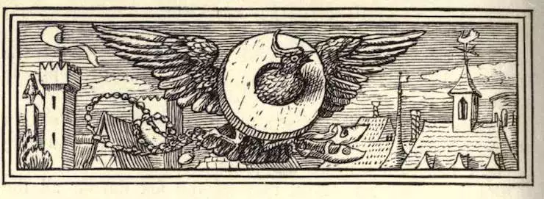
The Juniper Tree Part 2
Then the bird went and sat on a linden tree which stood in front of the mill, and sang:
My mother, she killed me,
My father, he ate me,
My sister Marlene,
Gathered all my bones,
Tied them in a silken scarf,
Laid them beneath the juniper tree,
Tweet, tweet, what a beautiful bird am I.
One by one, the apprentices laid down their tools and listened, until finally, the last apprentice heard, and dropped his chisel, and then all twenty burst into cheers and clapped and threw their hats in the air.
"Bird," cried the last apprentice, "how beautifully you sing. Let me hear that too. Sing it once more for me."
"Oh no," said the bird, "I do not sing twice for nothing. Give me the millstone, and then I will sing it again."
Then the bird came down, and the twenty millers took a beam and lifted the stone up. Yo-heave-ho! Yo-heave-ho! Yo-heave-ho!
The bird stuck his neck through the hole and put the stone on as if it weighed nothing at all, then flew to the tree again, and sang:
My mother, she killed me,
…
Tweet, tweet, what a beautiful bird am I.
When he was finished singing, he spread his wings, and in his right claw he had the chain, and in his left one the shoes, and around his neck the millstone. He flew far away to his father's house.
In the room the father, the mother, and Marlene were sitting at the table. The father said, "I feel so contented. I am so happy." "Not I," said the mother, "I feel uneasy, just as if a bad storm were coming." But Marlene just sat and cried and cried.
Then the bird flew up, and as it seated itself on the roof, the father said, "Oh, I feel so truly happy, and the sun is shining so beautifully outside. I feel as if I were about to see some old acquaintance again."
"Not I," said the woman, "I am so afraid that my teeth are chattering, and I feel like I have fire in my veins." Marlene sat in a corner crying. She held a handkerchief before her eyes and cried until it was wet clear through.
Then the bird seated itself on the juniper tree, and sang:
My mother, she killed me,
The mother stopped her ears and shut her eyes, not wanting to see or hear, but there was a roaring in her ears like the fiercest storm, and her eyes burned and flashed like lightning.
My father, he ate me,
"Oh, mother," said the man, "that is a beautiful bird. He is singing so splendidly, and the sun is shining so warmly, and it smells like pure cinnamon."
My sister Marlene,
Then Marlene laid her head on her knees and cried and cried, but the man said, "I am going out. I must see the bird up close."
"Oh, don't go," said the woman, "I feel as if the whole house were shaking and on fire." But the man went out and looked at the bird.
Gathered all my bones,
Tied them in a silken scarf,
Laid them beneath the juniper tree,
Tweet, tweet, what a beautiful bird am I.
With this the bird dropped the golden chain, and it fell right around the man's neck, so exactly around it that it fit beautifully. Then the man went in and said, "Just look what a beautiful bird that is, and what a beautiful golden chain he has given me, and how nice it looks."
But the woman was terrified. She fell down on the floor in the room, and her cap fell off her head. Then the bird sang once more:
My mother killed me.
"I wish I were a thousand fathoms beneath the earth, so I would not have to hear that!"
My father, he ate me,
And the wife fell down as if she’d been stunned, and her fingernails were scratching at the floor.
My sister Marlene,
And Marlene wiped her eyes and got up. "I too will go out and see if the bird will give me something," she said, and ran outside.
Gathered all my bones,
Tied them in a silken scarf,
As he said that, the bird threw down the little red shoes.
Laid them beneath the juniper tree,
Tweet, tweet, what a beautiful bird am I.
Marlene put on the shoes, and found that they fitted her perfectly. She was delighted, and she danced and skipped into the house and said, “Oh, what a beautiful bird! I was so sad when I went out, and see what he’s given me! Mama, look at these lovely shoes!”
"No! No!" cried the woman, jumping to her feet and with her hair standing up like flames of fire, "I feel as if the world were coming to an end. I too, will go out and see if it makes me feel better."
And she ran out of the door and out on to the grass, and – bam! The bird dropped the millstone on her head, and she was crushed to death.
The father and Marlene heard the crash and went out. Smoke, flames, and fire were rising from the spot, and then came a breath of wind and cleared them all away; and when they were gone, there was little brother standing there. And he took his father by one hand and Marlene by the other, and all three of them were very happy; and so they went inside their house and sat down at the table and ate their supper.

