Athletics Field Events

The Javelin Throw

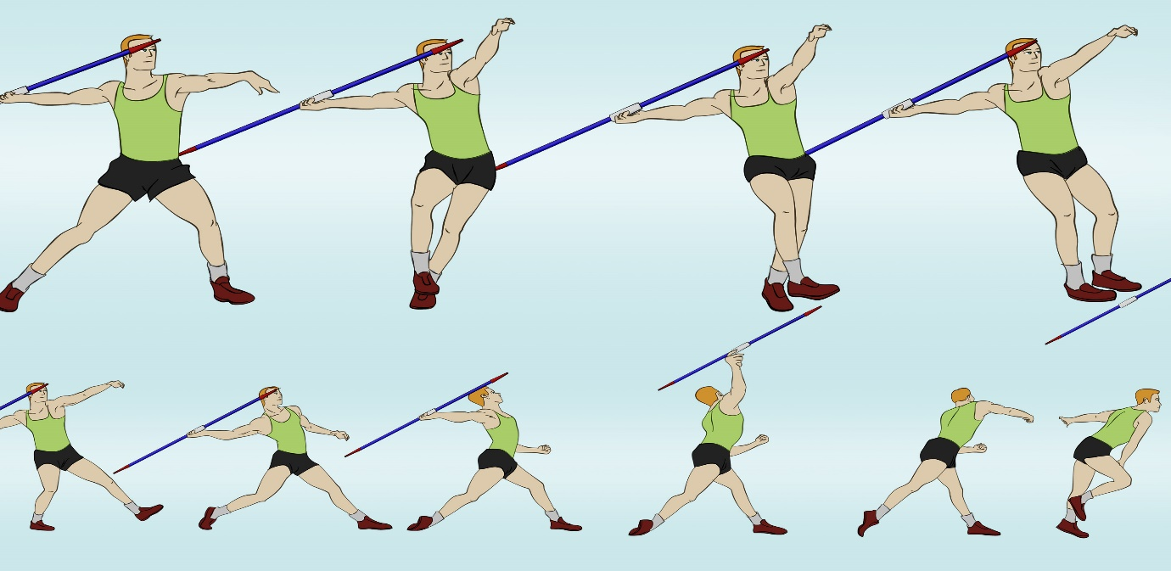

The One-Step Throw

- Step 1: Hold the javelin at a height above your head firmly and position it parallel to the ground.
- Step 2: Put your both feet tightly close to each other, facing them in the direction of the throw.
- Step 3: Put the palm under the javelin.
- Step 4: Pull the javelin back with your shoulder as far as possible. However the position of the javelin should be still parallel to the ground and facing ...
- Step 5: If you are a right handed thrower, then step forward with your left foot and throw it violently in the forward direction.
- Step 6: Without pulling down towards the shoulders, the throwing hand position should be kept high throughout the throw.

The Shot Put

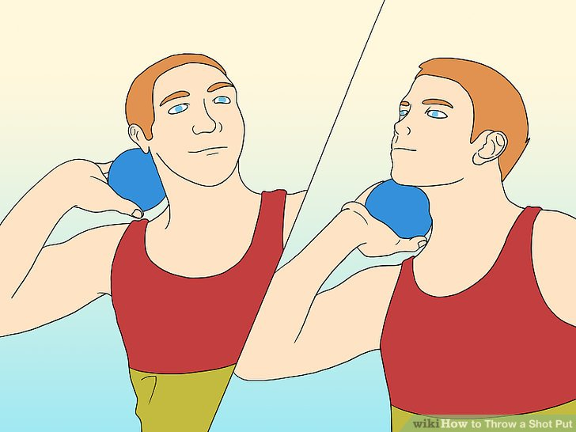
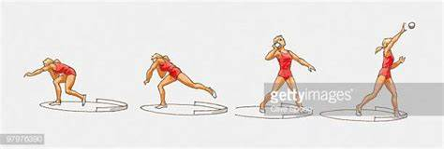

Step 1: Holding the shot
Place the shot at the base of your fingers, not the palm. Spread your fingers slightly apart and use your thumb to prevent the shot from rolling off.
Step 2: Starting position

Press the shot to the area of the neck beneath your jaw. Keep your elbow high, so that it appears horizontal to your shoulders. If the shot drops below your shoulder during the put, it will be considered a foul throw. Keep your feet wide apart, and bend the right leg, so that you tilt backwards. Twist your body so that you face the opposite direction of your target.
Step 3: Putting the shot
When you are ready, push off with your back foot and twist your hips, and then your body to face the target direction of your put. Extend your arm and propel the shot into distance at a 45 degree angle. When you shoot the shot, flick your wrist in a way similar to how you would shoot a basketball or netball.
The Discus

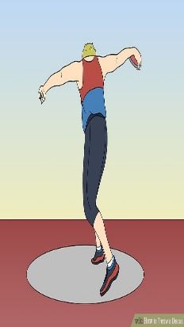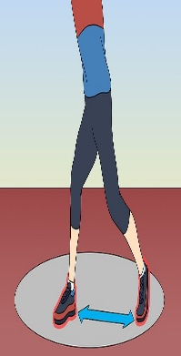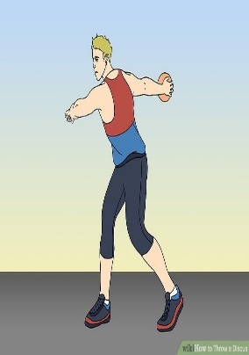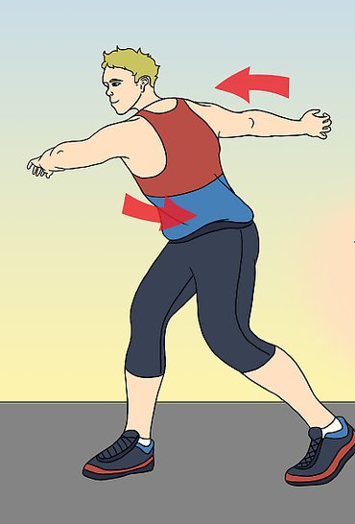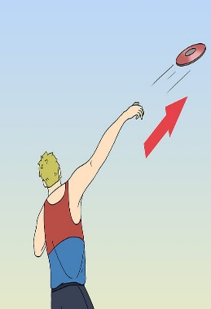
Step 1: Holding the discus
You do not actually grip it. Place your thumb on the plate. The rest of your fingertips should spread equally apart and extend over the rim of the discus. The discus will rest on the joints closest to the fingertips.
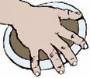
Step 2: Preparing for a standing throw
Stand with your left shoulder pointing at the target and your body facing the direction perpendicular to your shoulder (for right-handers). Keep your feet shoulder-width apart. Bend your knees slightly. Hold the discus to your front, with your throwing hand, palm down. Your other hand should support the discus from below to prevent it from falling.
Step 3: Executing a standing throw
Now that you’re in position, swing your throwing arm far back, palm still facing down. Once your throwing arm is pulled back to a comfortable limit, swing the discus to the front. Ideally, you should push with your right leg, twist your hips, and snap your left arm across your chest to the left.
Step 4: Release
Finish up looking at the target, and your throwing hand should follow through at an angle where the discus would take off. To eject the discus, you sort of squeeze it like a bar of soap, so that the discus spins off the index finger. The greater the spin, the more stable the flight.

