Tennis Techniques – Forehand, Backhand and Serve Techniques

Tennis Serve
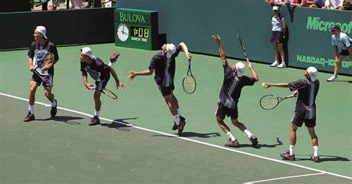

Step 1: Get into position - stand behind the baseline, on the side opposite the service box where you'll be serving. You should stand sideways, pointing your left foot to the opposite post of the net, with your right foot being parallel to the court.
Step 2: Grip the ball and racket correctly - Grip the ball lightly toward the fingertips rather than in the palm. Bring your ball hand toward your racket to help line up the serve and shift your weight slightly forward.
Step 3: Toss the ball and bring your racket behind you - You should toss the ball high up in the air, a little bit in front of you, so you have momentum when you serve the ball; remember that you can "fall in" to the court after you make contact with the ball, so it's okay to toss the ball in front of you.
Step 4: "Scratch your back" with your racket - You should bring the racquet head up above behind you and bend your elbow so as to drop it behind your head, as if you were to scratch your back with the side of your racket. Bend your knees to help project the racquet head upwards; it will give the ball more power.
Step 5: Hit the ball with the "sweet spot" of the racket - Bring the racquet head up to hit the ball with as much speed as you can while keeping control. Your shoulders will rotate similarly to how they would if they were throwing a ball.
Step 6: Hit the ball at its highest point - you should hit the ball at the highest point that you can reasonably hit it at after you toss it. The higher the ball, the more easily you'll be able to generate speed, and the more likely it will be to clear the net.
Step 7: Follow through by bringing your racket down near the bottom - the end of the contact with the ball, snap your wrist downward to get the ball in the best position. Transfer the weight from your back leg onto your front leg to propel the ball forward.

Forehand Drive

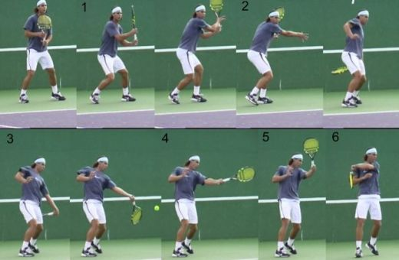-

Step 1. Stand Ready and Keep Moving - Getting in proper position is the most important element of any forehand. Step 2: Using the right Grip - Use a semi-western or western grip while executing a forehand.. With knees slightly bent, shoulders turned sideways; left hand stretched out in front of you, your racket should be behind your body in position for the back swing. Step 3: Backswing - Take your racquet back with your elbow close to your body and turn your upper body sideways onto the ball or the net. Move your weight onto the front leg and load your body for power to hit the ball. Step 4: Swing and contact - For a flat shot, keep your racket face straight as your ball contacts the sweet spot on the racket face. For topspin, close your racket face slightly and brush the ball to give it a good speed or defend against faster shots. Step 5: Follow through - Finish it right - After contact, continue to keep your head down and move your racket in the direction you want the ball to travel towards. Finish your follow through by keeping your arm relaxed and ensuring your racket is completely past your shoulder.
Backhand
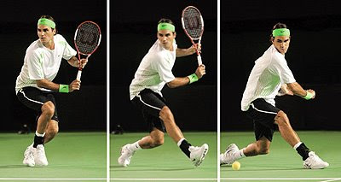
Step 1: Preparation - Like the forehand, getting in proper position is the most important element. It sets the foundation for good footwork and racket preparation which gives you the power, control and balance to produce a consistent shot. For a two handed backhand, grip your racket with your right hand on the bottom and your left hand on top. Step 2: Backswing - Take your racket back with your right elbow close to your body. Your right shoulder should be facing the net with your left hand gripping the racket, leaning slightly on your back leg preparing to shift the weight to the front. While extending your racket in front of you, move your weight onto the front leg and load your body for power to hit the ball. Step 3: Swing and contact - Gripping your racket tightly, keep your eye on the ball and turn your body towards its direction. Locking your elbow, continue extending the racket to the level of the ball. For one handed backhanders, focus on where the ball is to remove your left hand and quickly swing your racket forward. This creates the velocity and forward spin needed for a powerful single handed shot. For a double handed backhand, it is ideal that the racket should be parallel to the ground and positioned below the ball until moments before contact.

