Diary Entry Three: Social Media to the Rescue
First task: read and answer questions.
Nowadays, technology has introduced new ways of keeping a diary. Blogs, Twitter and Instagram are just a few of the ways people record what is happening to them day to day.
Idris Elba, March 16, Twitter: This morning I tested positive for Covid 19. I feel ok, I have no symptoms so far but have been isolated since I found out about my possible exposure to the virus. Stay home people and be pragmatic (sensible) I will keep you updated on how I’m doing. No panic.
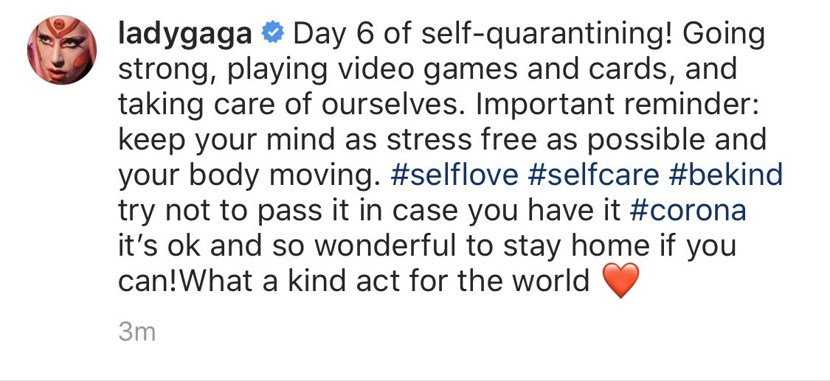
Answer these questions:
- What does Idris Elba mean when he says he has been “isolated” since he found he had been exposed to coronavirus?
- What two things does Lady Gaga say are particularly important?
- Why does she say that self-quarantining (self-isolation, or staying at home) is “a kind act for the world”?
Complete this sentence:
Idris Elba is in isolation because ________________________________________________
but_______________________________________________________________________
so_____________________________________________________________________________.
CHALLENGE: What vital (really important) element of punctuation does Lady Gaga omit (leave out)? Why?
Second task: write your diary.
Follow these instructions:
- Write today’s date.
- Write the title: Social Media to the Rescue.
- Write in first person and in your own voice.
- How did you feel about social media before the coronavirus crisis? Has that changed?
- How does social media help you and your family to keep in contact with friends you can’t meet?
- How does social media help other people to organise efforts to help each other?
- Does social media have any negative impacts during this crisis? (Hint: What about fake news?)

Use:
- A because…. but… so… sentence. For example: I am annoyed because I can no longer go to my tap-dancing class but at least I can dance at home so by the time this pandemic is over, I will be a world-class tap-dancer.
- Activist – someone who campaigns for a cause. EG: Greta Thunberg is an activist combatting climate change.
- Comforting – something that helps to calm you down. EG: Sometimes when I am worried, I like to read a book because I find it very comforting.
- Reassurance – a comforting feeling. EG Sometimes when I am worried, I speak to my friends and then I know that they are alright, and that is a great reassurance to me. Or: Sometimes, when I am worried, I speak to my friends and then I know that they are alright, and that is very reassuring to me. Or: Sometimes when I am worried, I speak to my friends and then I know that they are alright, and I am reassured by that.
- Perpetuate – to spread information, opinions or rumours, usually negative.
- Communal – for or by a group rather than individuals EG: Efforts to help the most vulnerable are nurturing (helping something to grow) a sense of communal resilience.

Diary Entry Four: Exploring the World (from the safety of home)
First task: read this extract from The Voyage of the Beagle by Charles Darwin. Charles Darwin (1809 – 1882) was an English naturalist and biologist best known for his contributions to the science of evolution. His theory that all species of life have descended over time from common ancestors is now widely accepted, and considered a foundational (basic) concept in science. At the age of 22, Darwin took part in a five-year voyage (sea journey) of scientific discovery aboard The Beagle.
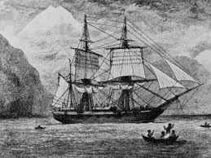
November 15th, 1835
At daylight, Tahiti, an island which must for ever remain classical to the voyager in the South Sea, was in view… The luxuriant vegetation of the lower part could not yet be seen, and as the clouds rolled past, the wildest and most precipitous (dangerously high) peaks showed themselves towards the centre of the island… After dinner we landed to enjoy all the delights produced by the first impressions of a new country, and that country the charming Tahiti. A crowd of men, women and children, was collected on the memorable point Venus, ready to receive us with merry faces. They marshalled us (led us) towards the house of Mr Wilson, the missionary (someone who wants to convert people to their own religion, usually Christianity) of the district, who met us on the road and gave us a very friendly reception… The common people, when working, keep the upper part of their bodies quite naked; and it is then that the Tahitians are seen to advantage. They are very tall, broad-shouldered, athletic, and well-proportioned… Most of the men are tattooed, and the ornaments follow the curvature of the body so gracefully that they have a very elegant effect. One common pattern, varying its details, is somewhat like the crown of a palm tree. It springs from the central line of the back, and gracefully curls round both sides. The simile may be a fanciful one, but I thought the body of a man thus ornamented was like the trunk of a noble tree embraced by a delicate creeper (a plant that climbs, like ivy).
Answer these questions:
- What is the name of the island that Charles Darwin is exploring?
- What does a missionary aim to do?
- Describe the men’s tattoos in your own words.
Complete this sentence:
Charles Darwin, ______________________________________________________, describes the people of Tahiti as _________________, ________________________ and ______________.
CHALLENGE: Do you think the extract conveys Eurocentric or racist views? If so, how?
Second task: write your diary.
Follow these instructions:
- Write today’s date.
- Write today’s title: Exploring the World (from the safety of home)
- This is a creative writing task.
- Plan your story, even if you just plan it in your head. It should include these elements:
- You are an explorer making first contact with people who live so far from other communities that they have never met an outsider.
- You may choose to explore the earth or a different planet.
- Describe the location – look at the beautiful way Charles Darwin describes Tahiti and the people who live there. If you can, use adjectives, similes, metaphors, personification. In any case, use your imagination.
- Describe your meetings.
- At first you are not sure whether you will be welcomed or attacked, but it becomes clear in some way (how?) that you are to be welcomed.
- Beware – when you describe the people you are meeting, how do you avoid being Eurocentric (seeing the world through the eyes of your own culture) or even racist?
- How do you recognise the rituals, traditions, beliefs, art and story-telling that indicate culture when you have never encountered this culture before?

Use:
- A “because…. but… so…” sentence. For example: I was frustrated because I was confined to home and I could not see the world, but I can travel anywhere in my imagination so I will create my own adventure.
- Ritual – a religious or solemn ceremony consisting of a series of actions performed according to a prescribed order. EG: In China, there is a tea drinking ceremony, a ritual which involves freshly boiling water, loose green leaves, a beautifully crafted terracotta teapot and tiny teacups like thimbles.
- Utopia – an ideal world. EG: I dreamed of a utopia in which our climate was restored to its natural state.
- Dystopia – the worst of all possible worlds. EG: A world such as that described in The Hunger Games is a dystopia, in which children are forced to kill others in order to survive.
- Benevolent – kind, good. EG: She was a benevolent leader whose policies benefitted the poor.
- Malevolent – unkind, evil. EG: He had a malevolent gleam to his eye and I knew that I should not trust him, or he would betray me.

