Second World War (WW2) Year 8
 | Date | Key events
1 | September 1, 1939 | Germany invades Poland
2 | September 3, 1939 | Britain and France declare war on Germany (start of WW2)
3 | January, 1940 | Rationing introduced across the UK
4 | May to June, 1940 | Dunkirk evacuated and France surrenders to Germany  Germany uses blitzkrieg to take over much of Western Europe
5 | July, 1940 | Germany launches air attacks on Great Britain (The Battle of Britain and the Blitz begins)  Germany, Italy and Japan signed the Tripartite Pact creating the axis alliance
6 | December 7, 1941 | The Japanese attack the US navy in Pearl Harbor. The next day, the  USA enters the war fighting with the allies
7 | June 6, 1944 | D-day and the Normandy invasion. Allied forces invade France and  push back the Germans
8 | April 30, 1945 | Adolf Hitler commits suicide
9 | May 7, 1945 | Germany surrenders & victory in Europe is declared the next day
10 | August 1945 | Atomic bombs dropped on Hiroshima & Nagasaki, Japan by the US  killing approximately 226,000 people
11 | September 2, 1945 | Japan surrenders signaling the end of WW2
12 | July, 1954 | Rationing ends in the UK

Leaders
1 | Adolf Hitler | Leader of the Nazi Party and Chancellor of Germany, 1933 - 1945 (also referred to as  the Führer meaning leader)
2 | Winston  Churchill | UK Prime Minister, 1940 - 1945 (and again  from 1951 - 1955)
3 | Neville Chamberlain | UK Prime Minister, 1937 - 1940 (infamous for failed attempts to satisfy Hitler’s  demands prior to the war)
4 | Franklin D.  Roosevelt | US President, 1933 – 1945 (took the US into  the war following the Perl Harbor attacks)
5 | Harry S.  Truman | US President, 1945 – 1953 (responsible for  the decision to drop Atomic bombs on Japan)
6 | Joseph Stalin | General Secretary of the Communist Party  and Leader of the USSR, 1929 - 1953
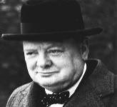
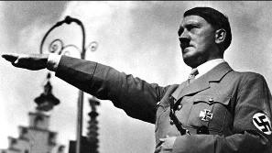
‘History will be kind to me for I intend to write it.’
Churchill

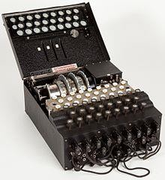
‘It is not truth that matters, but victory’ – Hitler (performing Nazi salute above)
Enigma machine
 | Term | Definition
1 | Allies | Countries which fought on the British side (including: USA, Great Britain, France, Russia (1941-1945))
2 | Evacuee | Someone who was evacuated, moved from a danger area to a safer place (normally from the cities to  rural areas)
3 | Black out | System of ensuring no lights were visible after dark so that buildings could not be spotted by enemy  planes
4 | Rationing | The controlled distribution of scarce resources (mainly food & clothing)
5 | Air raid shelter | A building to protect people from bombs dropped by planes  Anderson Shelter: Made of corrugated iron. Usually at the end of the garden  Morrison Shelter: Metal cage used inside the house. Could double as a kitchen table
6 | Trenches | A long, narrow ditch used for troops to shelter from enemy fire or attack
7 | Axis | Countries which fought on the German side (including: Italy, Germany, Japan, Russia (1939-1941))
8 | Nazi | Member of the fascist German political party which came to power in 1933. Symbol = swastika
9 | Blitz | Series of aerial bombing raids on the UK, mainly cities including London, Bristol & Nottingham
10 | Holocaust | Mass murder of Jews and other groups of people by the Nazis
11 | Fascism | Right wing political view associated with not allowing opposition and total control by a dictator.
12 | Blitzkrieg | Translated as ‘lightning war’. German quick strike invasion of Western Europe
13 | Luftwaffe | The German Air Force (responsible for the Blitz)
14 | Enigma | A machine used by the Nazis to send coded messages

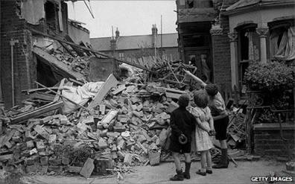
London during
the Blitz

