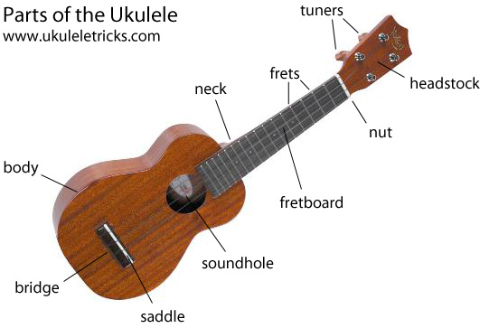

WORD BANK
Accurate: performing your part correctly
Chord: 3 or more notes played at the same time
Chorus: section of the song, usually very catchy and repetitive
Expression: adding emotion to your performance, for example by changing the volume
Fluent: performing your part smoothly with good flow
Improvise: create and perform something spontaneously or without preparation
Lyrics: the words to the song
Melody: The main tune to the song
Note: The pitch and duration of a sound
Pitch: How high or low a note is
Pulse: the regular beat to the song, helps to keep you in time
Rhythm: a strong, regular repeated pattern of sound.
Riff: a short, catchy repeated musical phrase
Solo: performance with only one instrument/voice
Strumming: playing a ukulele by sweeping the thumb, finger or a plectrum up or down across the strings
Tabs: form of music notation for ukuleles and guitars
Tempo: the speed at which a passage of music is played
Verse: section of a song, usually tells a story

INTERESTING FACTS

- The ukulele literally means ‘jumping flea’. It was given its name due to the fast motion of the fingers.
- The ukulele is from Hawaii.
- The four strings on the ukulele are tuned to the notes G, C, E, A. You can use the phrase Good Children Eat Apples to remember the notes.

