Basketball

Playing area and players

Playing area
A competitive basketball match is played on a large rectangular court and is usually made of highly polished hardwood. Basketball courts come in different sizes but an official NBA (National Basketball Association) court is measured at 28.7 m (94 ft) long and 15.2 m (50 ft) wide, while youth courts should be 26 m (84 ft) long and 15 m (50 ft) wide.
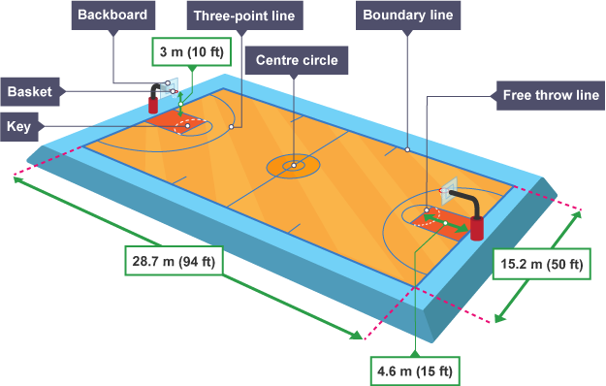

Players
A basketball team consists of five players per side and is divided into different positions. Like most sports the team has very clear roles to support their overall success:
- Point guard - this is usually the smallest player on the team and has outstanding passing and handling skills. Their role requires them to move the ball up court and begin all attacking positions.
- Shooting guard - this player is normally quite tall in stature but is required to have great distance-shooting skills. A basketball team will usually try to set an attacking screen and allow the shooting guard to come off teammates and shoot, pass, or drive at the basket.
- Small forward - this player has a versatile role and is required by the team to be strong, athletic, have good handling skills, and the ability to shoot effectively from short and long range.
- Power forward - as the name suggests this player is required to be very explosive and powerful to ensure they are able to catch passes and hit shots near the basket.
- Centre - this player is usually the tallest player and is required to post up in attacking positions. Their height allows them to receive the ball with their back to the basket and deploy basic skills to make a shot.
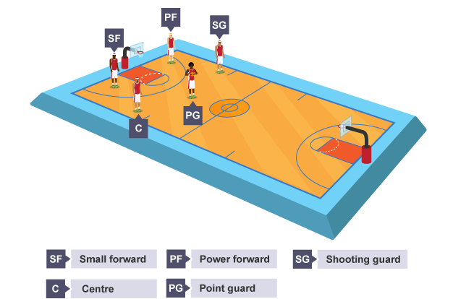

Dribbling the ball
Good dribbling skills enable a player to keep control of the ball, travel past a defender, or to simply move the team forward.

Stage one
- Stand with feet shoulder width apart in opposition.
- Stand on the balls of your feet.
- Knees slightly bent and the trunk bent forward at the waist.

Stage two
- Push the ball downwards using fingertips.
- Extend the shoulder and elbow.
- Flex the wrist.
- Keep the head up and the ball slightly out in front (max 1 m).
- Keep the ball at waist level with your hand on top of the ball.
- Absorb the impact with fingertips and let the wrist flex and move the ball.
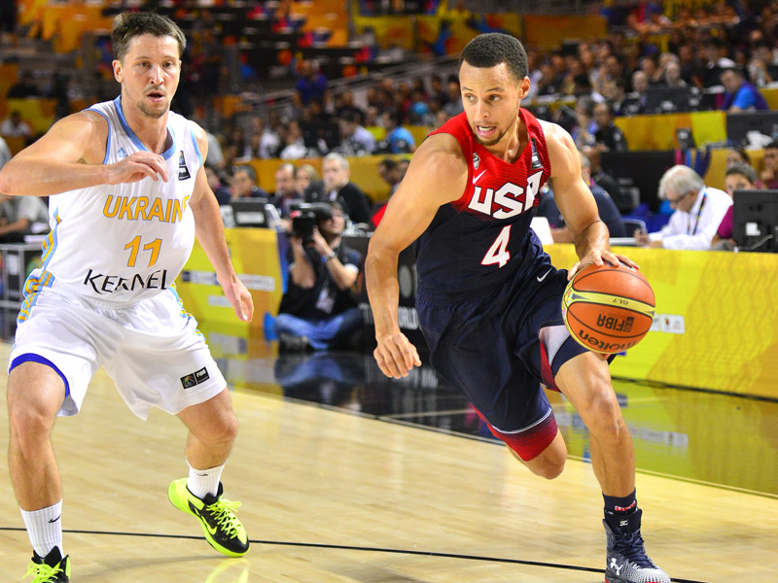

Jump shot
The purpose of the jump shot is to allow the shooter to take aim from a higher position and therefore prevent a defender from blocking it.

Stage one
- Place feet shoulder width apart, toes pointing straight ahead, and knees bent.
- Place non-shooting hand on the side of the ball and the shooting hand at the back of the ball, with the elbow tucked in.
- Hold the ball at chest height.

Stage two
- Extend the legs/ankles by jumping straight up.
- Whilst in flight, extend back, shoulders and elbow.
- Flex the wrist and fingers forwards and release the ball at the highest point.
- After release, fingers should be pointed at the target, with the palm facing down.
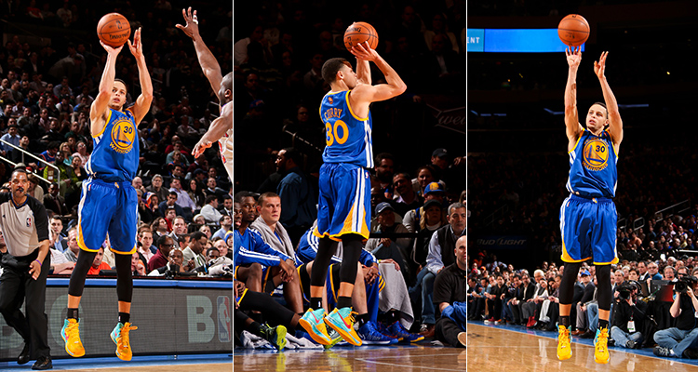

Lay-up
A lay-up provides a player with the opportunity to drive at the opponent's basket, jump close to the target and release the ball safely at the backboard. When used effectively it has the highest percentage chance of scoring points.

Stage one
- Dribble to the side of net.
- When a few metres away from the basket, hold the ball with both hands on the shooting hands side of the body.
- Place the non-shooting hand on the side of the ball, and shooting hand on top of the ball.

Stage two
- The last step before the lay-up jump should ensure that take off foot is opposite to the shooting hand (left foot/right hand).
- Flex the knee at takeoff.

Stage three
- Whilst jumping, extend the shooting knee and raise the ball up.
- Bring the ball between the shoulder and ear.
- Direct the wrist and fingers straight at the basket and release the ball at the highest point.
- Complete the follow through with the arm up and palm facing down, and hold until the ball has reached the basket.

