Recommended reading for KS3

Percy Jackson series by Rick Riordan
Harry Potter series by J.K Rowling
Dealing with Dragons by Patricia C. Wrede
Eragon by Christopher Paolini
The Subtle Knife by Philip Pullman (sequel to Northern Lights)
The Girl Who Drank the Moon by Kelly Barnhill
The Hate U Give by Angie Thomas
The Hobbit by J.R.R. Tolkien
Hoot by Carl Hiaasen
Where the Mountain Meets the Moon by Grace Lin
Blue Dolphins, by Scott O’Dell
Noughts and Crosses by Malorie Blackman
As Brave as You by Jason Reynolds
The Crossover by Kwame Alexander
Challenging texts for Y8s:
The Hitchhiker’s Guide to the Galaxy by Douglas Adams
Pigeon English by Stephen Kelman
The Catcher in the Rye by J.D Salinger
To Kill A Mockingbird by Harper Lee
The Fault In Our Stars by John Green
The Perks of Being a Wallflower by Stephen Chbosky
The Divergent series by Veronica Roth
The Curious Incident of the Dog in the Night-time by Mark Haddon

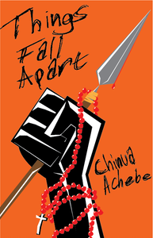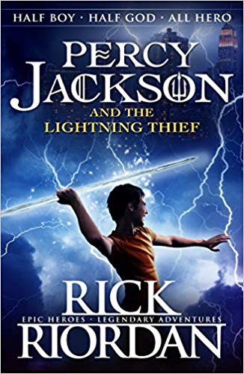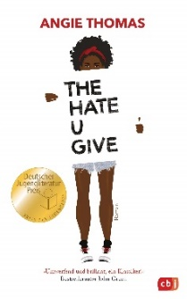

Teachers recommend:
Mr Healy: “I really recommend The Subtle Knife – if you liked Northern Lights, this one’s even better!”
Ms Sampson: “Murder on the Orient Express by Agatha Christie. Such a great, addictive mystery.”
Mr Hall: “The Boy in the Striped Pyjamas explores coming of age, grief and love in an eloquent way.”
Mr Bosela: “To Kill A Mockingbird introduces young readers to topics like morality, themes which are so important to think about at that age.”
Ms Simpson: “Everyone should read The Hobbit, because it will lead you on to The Lord of the Rings, which everyone should also read!”
Mr Clerkin: “The Lion, the Witch and the Wardrobe, by C.S Lewis. The perfect example of escapism.”
Ms Kent: “The Kite Runner by Khaled Hosseini. Despite the more mature themes, it gives an eye-opening account of friendship in the face of difficulties.”

