Year 7 History Project
You should spend at least 2 hours a week on this project.
This does not have to be at once and can be in 30 minute chunks.
By the end you should:
- Be able to describe what the industrial revolution was.
- Have an understanding of how it changed Britain.
- Have produced a piece of work demonstrating your new knowledge.

Industrial revolution
Read through the following on the Industrial Revolution:
https://www.bbc.co.uk/bitesize/guides/zvmv4wx/revision/1
Watch the following video:
https://www.youtube.com/watch?v=3Efq-aNBkvc

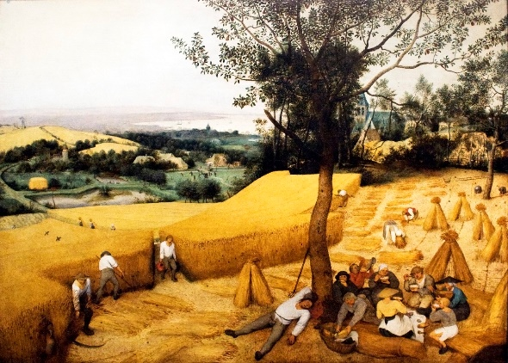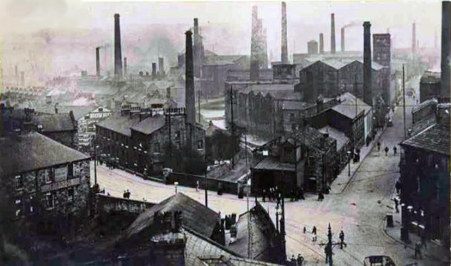
Answer the following questions in full sentences.
- Compare the two images.
- What are the differences between the two images?
- Why do you think there are these differences?
- The definition of a turning point is a moment in history which results in a massive change.
- Why do you think the industrial revolution has been described as a turning point in history?
- Write down a list of changes that occurred (happened) during the Industrial Revolution. Think about the following;
- Job
- Towns
- Where people live
- Watch the opening ceremony of the 2012 London Olympics: https://www.youtube.com/watch?v=HBITyBdRv_Q
Why do you think the industrial revolution was used in the opening ceremony of the 2012 London Olympics?
- How accurate is the opening ceremony of the 2012 London Olympics compared to what you know about the Industrial Revolution?

For your project you need to either:
(Choose 1)
- Write a commentary on the London 2012 Olympics opening ceremony explaining the changes taking place during the industrial revolution.
- Draw 4 pictures from before to after the industrial revolution showing change from picture to picture.
- Write a diary entry of someone who lived through the industrial revolution explaining the changes that took place.
- Make a model industrial town. Take a picture and annotate it. This could be done out of lego, cake, cardboard etc.
- Write out a plan for your own London 2012 opening ceremony on the Industrial Revolution and explain why you have decided to do it like that.

Other useful sites
https://kids.britannica.com/kids/article/Industrial-Revolution/353290
https://www.historylearningsite.co.uk/britain-1700-to-1900/industrial-revolution/children-in-the-industrial-revolution/

