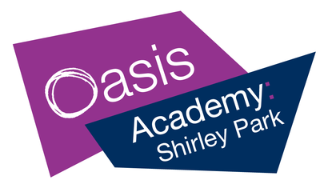
Year 6 Weekly News

Dear families,

Year 6 have been very busy with assessments this week. These assessments add to our knowledge of the children’s progress so far and highlight areas that we need to revisit. The children have all worked very hard and we are incredibly proud of their progress and behaviour for learning throughout the whole week. Already, the progress we are seeing from September to now is astounding!

Next week, in English we will be exploring and writing about Pompei (linking to our Geography lesson) before we start our new class books, Shackleton and Survivor. For our maths lessons, we will be revisiting the topics of area and perimeter before moving on to 3D shapes and calculating volume. In RE, we will be learning all about the Aqiqah ceremony within Islam. In computing, we are continuing our topic of online safety, learning about our digital footprint. In Geography, we are learning about the features of a volcano and what happens when a volcano erupts. In Art, we are continuing to use the grid method to improve our sketching. In PE, we are learning the skills needed to play tennis. In Spanish, we are learning to give and follow simple instructions and we will practise this by playing the Spanish version of Simon Says.

We give you this information so that, if you want to, you can use all the information above to talk to your children about their learning or plan activities and trips, for example.

Attendance
It is very important that all children come to school every day to ensure that they can maximise their learning. We understand that children do become unwell, and we would like to offer any assistance we can to support you in getting your child back to school, so please do contact the school on the first day of absence if your child is going to be absent for any reason.
Attendance Champion for last week was Redwood class from Skylark house with 98% attendance.

Key dates:
15th November Odd Socks Day to mark the start of Anti-Bullying Week.
Thursday 18th November – Christmas card competition deadline.
Saturday 4th November – Frost Fair at Stroud Green 9am-12pm. Reply to the PTA email if you want to book a pitch, or if you have any questions.

Best wishes,
The Year 6 team.

