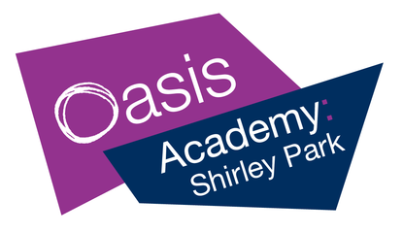
Year 6 Weekly News

Dear families,

This week started with ‘Odd Socks Day’ to introduce Anti-Bullying week, and many children wore an interesting combination of socks to support this wonderful cause. As the week has progressed, we have been thinking about how using one kind word can have a positive impact on others.

Unfortunately, Mr Sharp has broken his leg and requires surgery, therefore he will not be in for the foreseeable future. Please direct any queries to your child’s class teacher so that it can be directed to the appropriate person.

Next week, in English we will be starting new class books Shackleton’s Journey and Survivor. For our maths lessons, we will be revisiting different methods that can be used to solve division problems. In Science, we will be identifying different microorganisms. In RE, we continue our exploration of the Aqiqah ceremony . In computing, we will be looking at the importance of balancing screen time with other activities which play an important role in our lives (such as reading and exercise). In geography, we are learning about the features of an earthquake and the impact they have on people’s lives. In art, we will be using the grid method to recreate the work of Kehinde Wiley. In PE, we are continuing to learn the skills needed to play tennis. In Spanish, we are learning to give and follow simple instructions.

Attendance
It is very important that all children come to school every day to ensure that they can maximise their learning. We understand that children do become unwell, and we would like to offer any assistance we can to support you in getting your child back to school, so please do contact the school on the first day of absence if your child is going to be absent for any reason.

After school collection
To enable staff to attend training, meetings and carry out essential marking and lesson preparation after school, we will resume fines for repeated late collection very soon. More information to come.

Key dates:
Saturday 4th December – Frost Fair at Stroud Green 9am-12pm.
Friday 26th November – PTA donation day. In return for wearing mufti clothes, we are asking for donations for the Christmas raffle.

Best wishes,
The Year 6 team.

